Trip report, Sulawesi and West Papua, May – June, 2023.

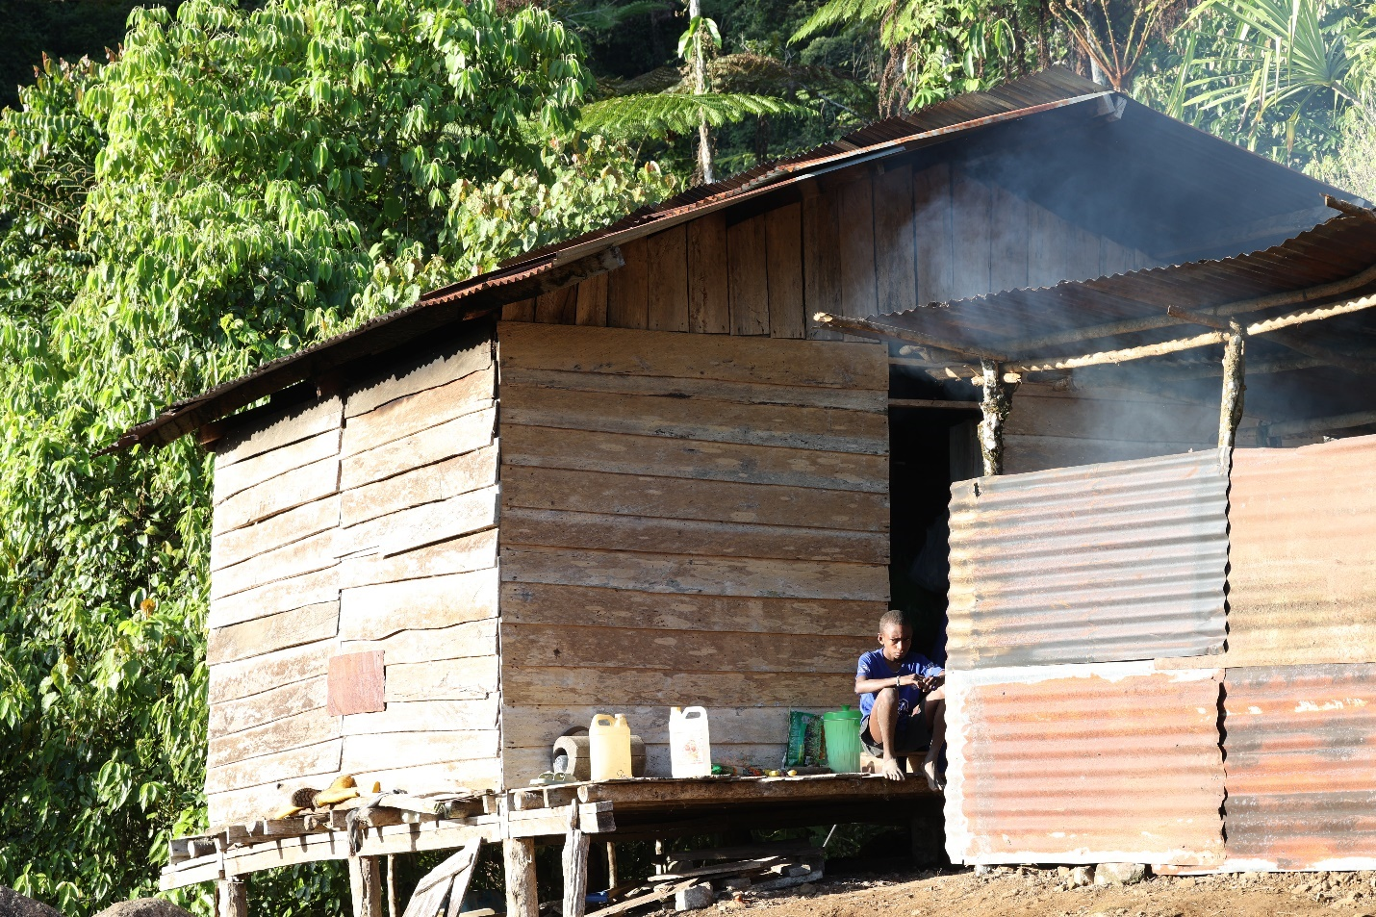

I had been talking with Jon Hall for some time following the tantalizing reports of mammals that Carlos Bocos had seen while guiding birdwatching trips to West Papua. A window of opportunity presented itself this June for what promised to be a fantastic trip into one of mammal-watching’s last frontiers and several of us jumped at the chance to join. Jon and Charles have already posted reports of this trip, but I thought I would add my own perspective for those interested. Jon’s report contains photos of nearly all the species we saw – I have added a few additional shots here.
Looking at flights, I realized that most of them passed through Sulawesi on the way to West Papua. In my mind, more is more, so I decided to make a brief stopover in Manado in the hopes of seeing a babirusa. The flight from Vancouver to San Francisco was on time and uneventful. The onward flight from San Francisco to Singapore was delayed over an hour, causing a bit of consternation about my connection. Fortunately, Singapore came through in its usual efficient fashion. The plane touched down about 6:30 am, I was through the automated passport control and on the train to Arrivals to greet my bag which appeared at 6:48 am, then back upstairs to catch the train to Terminal One where I found the check-in for the next flight. The kindly airline attendant told me to relax and catch my breath. When a Singaporean is telling you to relax, you know you must be looking harried. In any case, the flight was caught in good time and it was on to Manado. I arrived in Manado about 1:30 pm and, after purchasing a visa on arrival, having my COVID19 vaccination paperwork checked and passing through immigration, was at the front door to be greeted by Bobby Lambaihang and two drivers. Given that we had a 14-hour drive ahead of us, Bobby’s wife had thoughtfully suggested he take two drivers rather than one. We were underway by 3:00 pm, passing through the sprawl of suburban Manado until we were eventually on the beautiful coastal road, busy with rush-hour traffic. After a couple of stops, the first for a delicious grilled tuna supper, and the second at the driver’s parents house for tea and coconut buns, we arrived at Nantu Forest just after five in the morning as the sun was starting to rise. The first mammal of the trip, which ran out of the park office and down the steps, was most likely a Black Rat. After breakfast of tea and packaged pastries at a small guest house in the village we started the short walk to the famous hide. We had a very brief glimpse of Heck’s Macaque and then were greeted by the sight of a half-dozen North Sulawesi Babirusas at the mineral lick. Initially all the babirusas were females or young, but eventually several males started showing up. Two Sulawesi Warty Pigs also made an appearance. Various babirusas appeared, coming and going through the day. At one point, nineteen individuals were visible at the mineral lick at one time, allowing for a leisurely observation of the full gamut of preferred babirusa activities, fighting, mating, rooting for food and wallowing, probably in that order. We left the blind mid-afternoon and had a little bit of time around the ranger station with nice sightings of two varieties of hornbills amongst other birds. We then hiked back to the village and started driving to Gorontalo, arriving about three hours later. The first restaurant we visited had plates of unappetizing cold food which looked like they had been sitting out for several days. For me this brought back unfortunate memories of numerous Sumatran stomach upsets, so we persevered on and found a place serving delicious grilled chicken, rice and water spinach for a modest price. We crashed at the Akbar Hotel for the night. The next morning, there was little water pressure but remarkably hot water, allowing for my first shower and shave in Sulawesi. Shortly after we started driving, Bobby yelled “stop”. A small group of Heck’s Macaques were feeding on figs by the side of the road, allowing for excellent views. By this stage, we were all feeling a bit tired and giddy and the driver was laughing like a hyena. We reached the outskirts of Manado about 6:30 pm and an hour later I was comfortably installed in a hotel which was clean and within a few minutes drive of the airport. I popped over to a nearby supermarket for a few supplies and an ATM visit where I had a close-up view of two Black Rats, then headed to bed.

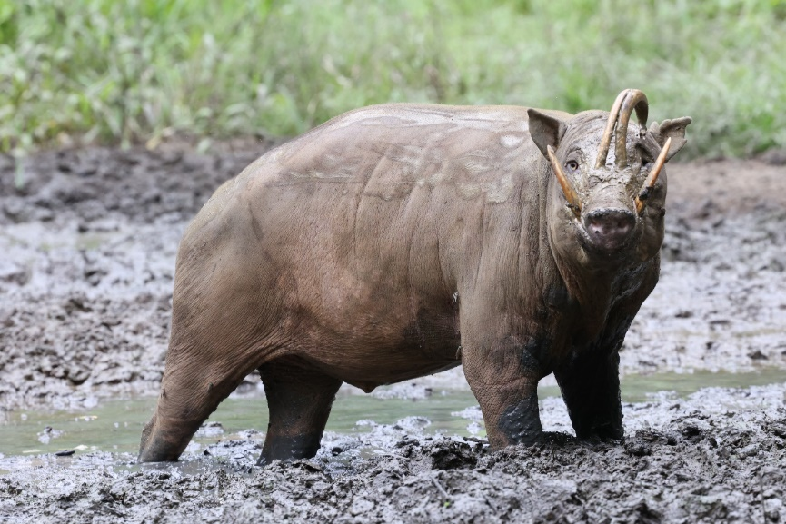
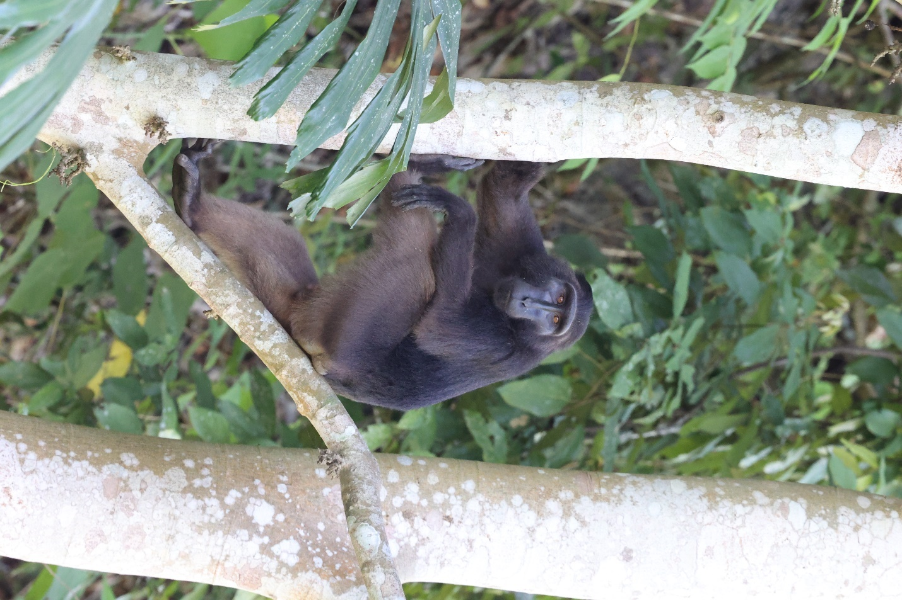
The next morning I was up by 4:00 am for a cold shower and a breakfast of nasi goreng, fried rice with boiled egg. A four-minute drive deposited me back at the enormous new airport. It always amazes me the number of flashy new airports across Asia. Airport staff were super polite, including not mentioning my full water bottle as it went through screening. I spent most of my time in the airport having my picture taken with complete strangers. According to Bobby, these pictures are often used to bolster people’s fictional stories of adventures with foreigners, etc. I believe there are now more pictures of me on various people’s phones in Manado than of any actual celebrity.
The flights on to Sorong and Manokwari were uneventful. I arrived about 2:00 pm and had a quick taxi ride to the Aston Nui, where I met up with the group, Carlos Bocos, Jon Hall, Venkat Sankar, Charles Foley and Nils Bouillard. After lunch we headed out to a bat cave in the forest just outside Manokwari. There were at least two species of bats present, Emballonura raffiana and Dobsonia minor. We stopped at a mall for snacks and other essential supplies, visited a local speakeasy for beers (Manokwari is ostensibly a dry town) and headed back to the hotel for a dinner of French fries and an early night.
The next morning I was up at 3:00 am for a lovely hot shower and a breakfast of eggs and sausage. We were scheduled to leave about four but this got delayed for half an hour or so. During the time spent waiting, we were able to see and bat detect a Papuan Pipistrelle flying around. The drive to the trailhead was interesting - our driver fell asleep briefly and went off the road at one point so Carlos appointed himself as the replacement driver. We arrived at the trailhead about 5:30 am to the sight of the entire village milling around. We grabbed day packs and started walking up the trail to Gunung Mupi. This hike had been described to me previously as “incredibly arduous”. If anything, this was an understatement. The track heads uphill, crosses back and forth over a river four times and then, for the last four hours of hiking, ascends an incredibly steep and muddy trail. The walk was enlivened briefly by the sighting of Rusa Deer by several people. We arrived at the camp about 2:00 pm. The camp consists of a sizable wooden building with several small rooms, a neighbouring church which we also utilized for sleeping, and another small building for meal preparation. Woven mats were provided to sleep on the floor. We had a lunch of water spinach, Spam, and rice and then a lie-down for a couple of hours. My lie-down was spent dealing with agonizing leg spasms. Five days of nearly continuous sitting followed by nine hours of steep hiking was obviously engendering a protest vote from my legs. We then had heavy rain for several hours which ended shortly after dark. In a tree near camp we had views of a Papuan Glider, followed by a hike around camp which was exceptionally productive. We saw our first Reclusive Ringtail, had a Common Blossom Bat (Syconcyteris australis) flying around, and got a good view of a Feather-tailed Possum as well as a Great Bare-backed Fruit Bat (Dobsonia moluccensis magna). We also had views of two Striped Possums. We were back to camp at about 10:00 pm feeling ecstatic.

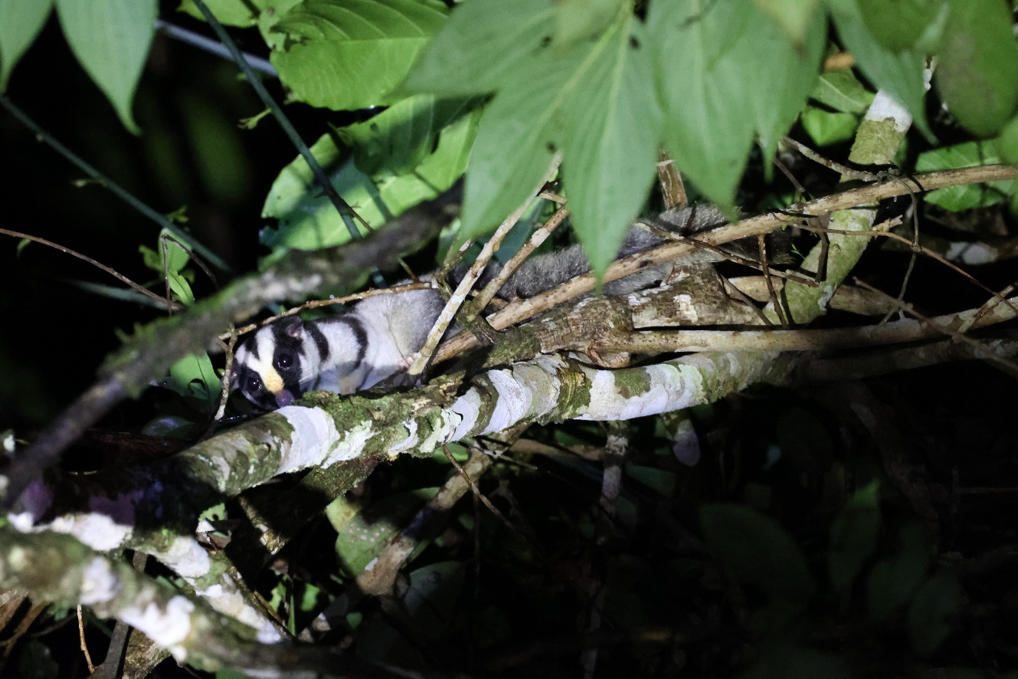
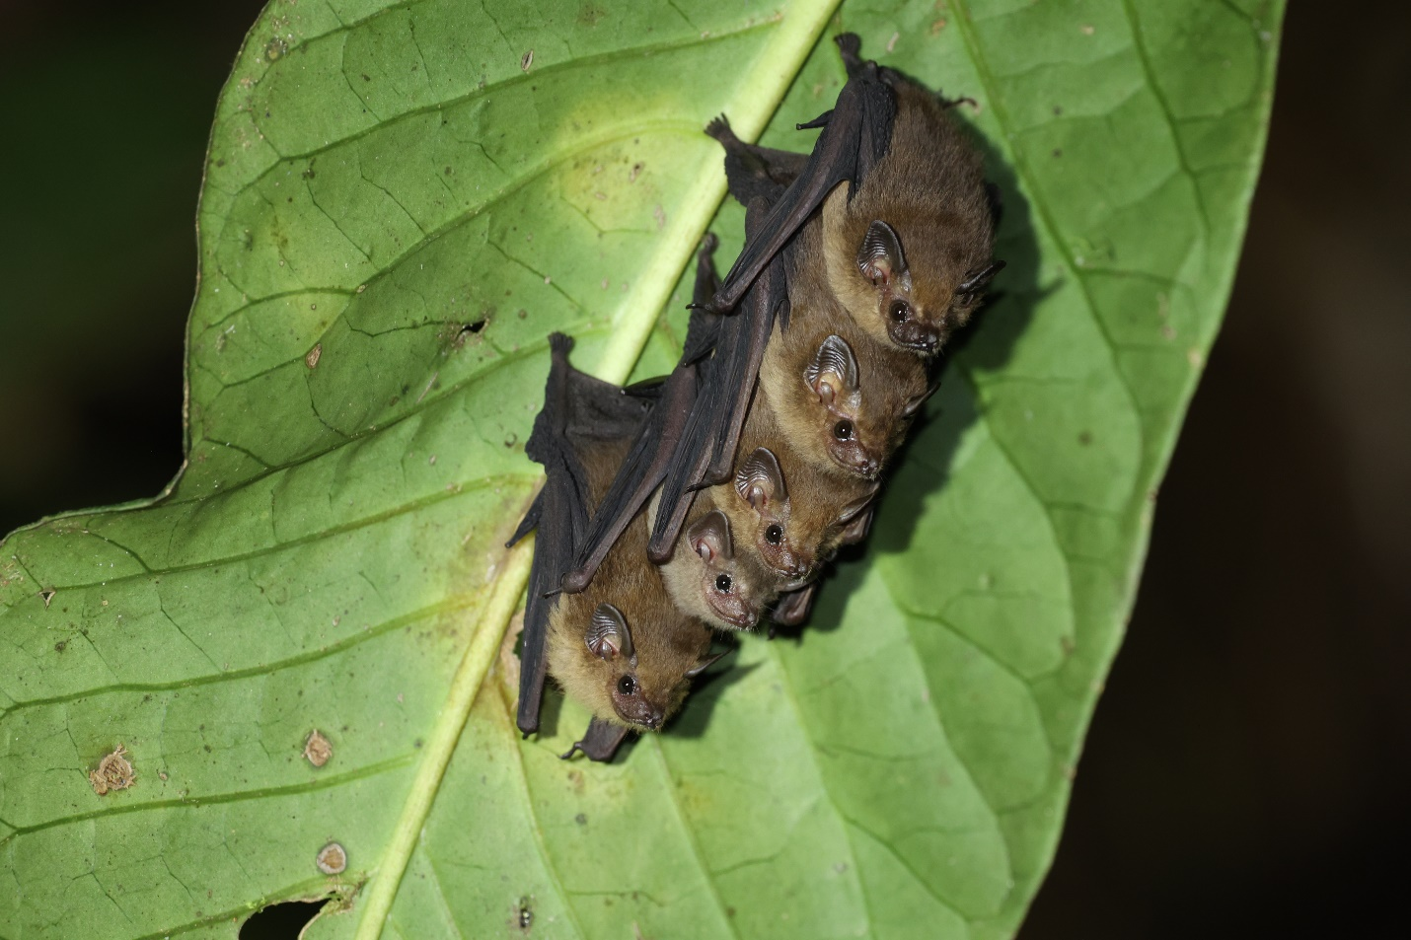

The subsequent few days followed a similar pattern. Children would be laughing and shouting from 5:00 am onwards, generating an early morning enthusiasm rare in my own household. Breakfast generally consisted of omelettes or scrambled eggs with garlic and onions, toast, jam and instant three-in-one coffee. The first morning I did a walk to a nearby birdwatching hide and managed to see Black Sicklebill, and Lesser Bird of Paradise. Lunch was comprised of noodles, bits of chicken, water spinach and the uncontested highlight, Beng Beng chocolate bars. We received word that the trackers had located a couple of Vogelkop (Black), or Ursine, Tree Kangaroos. We hiked about an hour up a very steep trail behind the camp, to be greeted with a view of a Black Tree Kangaroo mother with her young. There are few cuter creatures on planet Earth. We hiked back down to camp for a brief lie-down. Rain continued off and on but had stopped by about 8:00 pm so we headed out on the trails for another productive night walk. A rodent in a tree was identified as Gray-bellied Tree Mouse, Pogonomys sylvestris. We then had good views of the Northern Blossom bat, Macroglossus minimus. A Raffray’s Bandicoot ran across the trail just behind us. The next mammal spotted was a Ground Cuscus, located high in a tree. One of the guides shook the tree gently and the Ground Cuscus released its hold, stretched out its limbs and BASE jumped about 30 feet to the ground. It landed with a concerning thump, but scuttled away so quickly the guides were unable to catch. We came across five Dark Sheath-tailed bats (Mosia nigrescens) in a row on a leaf and then a Northern Common Cuscus looking surprisingly brown. We initially thought the next cuscus was a Common Spotted Cuscus, but photos reviewed after we returned home suggested an unusually coloured Northern Common Cuscus, as the ears and a faint dorsal strip were visible. To me this once again highlighted the importance of good photographs and careful review to definitively identify species. So many species are easy to initially misidentify in the dark, even by careful and experienced observers. We came across several Common Blossom Bats, as seen the previous night, and headed back to camp at about 11:30 pm for a quick drink. Afterwards, we hiked to the nearby river, finding a Black-tailed Melomys (Melomys rufescens) and at least one Northern Common Cuscus along the way. We arrived back to camp about 1:30 am, tired but happy.

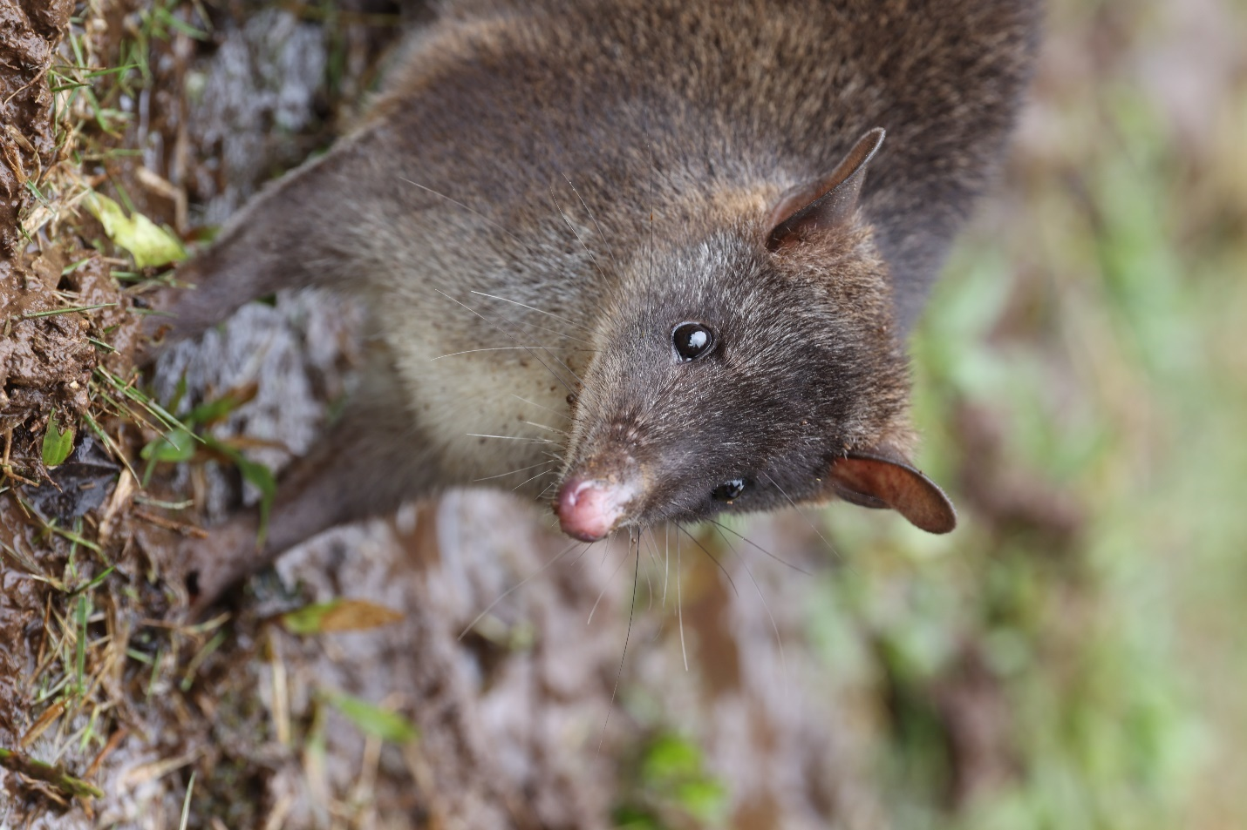

On June 6 the camp awoke at its usual early hour. I walked out to the sicklebill hide about 7:00 am for views of Black Sicklebill, Lesser Bird of Paradise and Riflebird again. The day was initially sunny, providing an opportunity to wash some laundry, but heavy rains settled in for the afternoon so the main activities turned to napping and chatting. We saw a number of Syconycteris that night, as well as a Miniopterus macrocneme and Rousettus amplexicaudatus. The evening hike revealed Common Spiny Bandicoot, Chestnut Tree Mouse (Pogonomys macrourus), and a mystery rat with white tail seen by Carlos, likely a Leptomys and possibly an undescribed species. A short-faced tree rat with a dark black tail and ears that may have been Chiruromys lamia, Feather-tailed Possum on the main trail and a Striped Possum on the pandanus fruit in front of the bird of paradise hide rounded out the night’s sightings.
The morning of June 7 arrived accompanied by lots of rain, followed by more rain throughout the day. Laundry put out to dry yesterday was probably even wetter today. I went up to the bird of paradise hide and managed to see an endemic Western Parotia, one of the birds of paradise featured in an episode of Planet Earth and a truly spectacular sight. We received word about 5:00 pm that another tree kangaroo had been found, so we quickly headed out, eventually coming across a male Black (Ursine) Tree Kangaroo. As dusk fell we continued further along the trail, seeing the first of several Arfak Ringtails, a Chestnut Tree Mouse (Pogonomys macrourus), several Round-eared Tube-nosed Bats as well as further Reclusive Ringtails, a Striped Possum, and a very brief look at a Common Echymipera. The highlight of the evening was a close, prolonged look at another mother and young Black Tree Kangaroo. The plan for the evening had been to climb up to a higher elevation in the hopes of encountering Stein’s Cuscus. The guides suggested a shortcut, a term which always fills my heart with dread. Tonight was no exception, as the “shortcut” turned out to be a horrendously steep and slippery climb with Hans and the other guides cutting trail as we went. Eventually we crossed the main trail from camp and, following it for a couple of hours, made our way back to camp. We were all so tired, wet and muddy that we took little time to look for anything on the way back and saw only a Northern Common Cuscus, arriving in camp about 1:30 in the morning with aching legs.
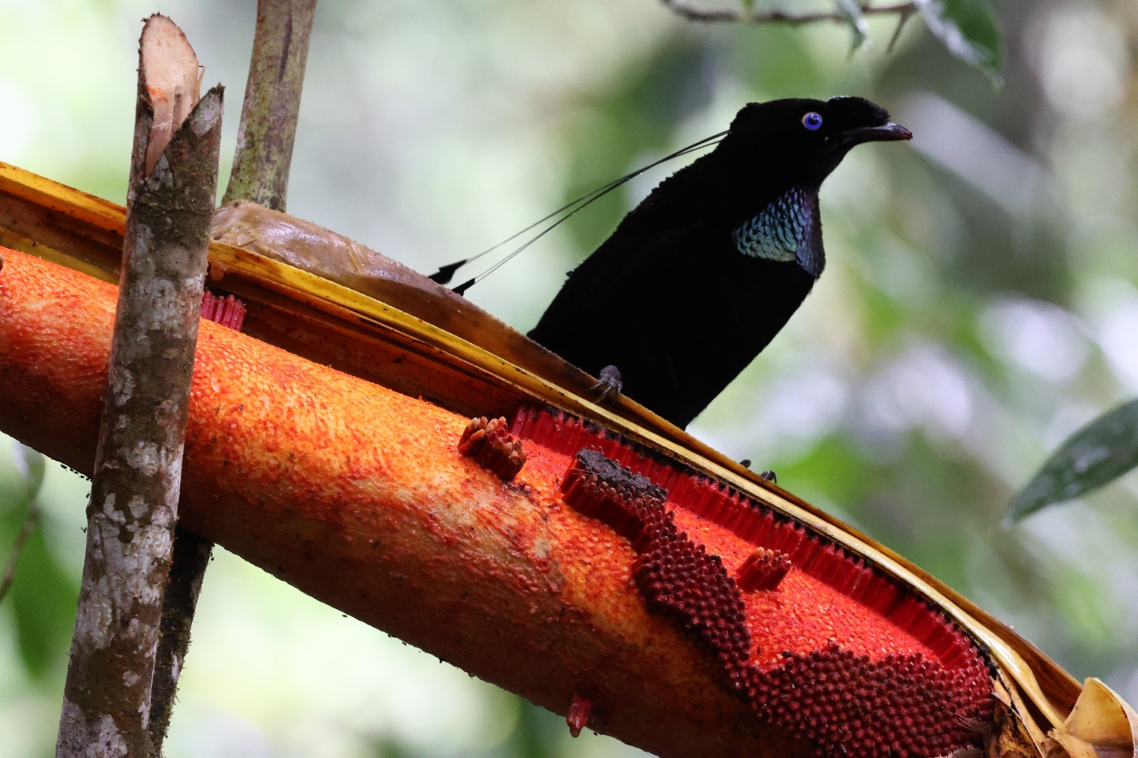
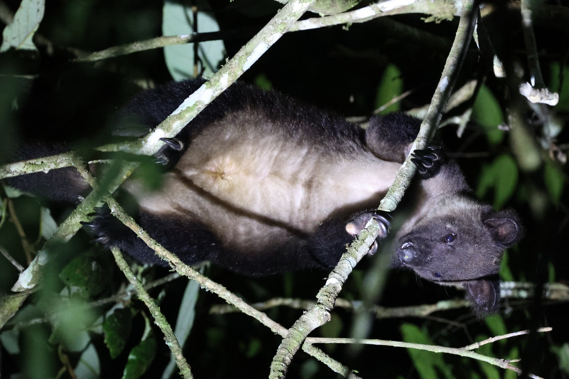

The next morning was enlivened by a report of another tree kangaroo reported high in a tree, which Hans said he was going to check out. To our surprise, this turned out to be a large male Grizzled Tree Kangaroo, which spent the day surveying the surroundings and allowing for good views. I think all of us were still sore from yesterday and so had a relaxing morning, lunch and then nap. As it was our last day on Gunung Mupi, we had a little ceremony and made a donation to the community for their work conserving the local wildlife, with Carlos delivering a heartfelt thank you to our hosts. Being delivered in Bahasa Indonesia, I understood very little of it but it appeared warmly received by the group who responded with reciprocal kind words of their own. On our night walk we saw our first D’Albertis Ringtail and an Unstriped Tube-nosed Bat (Paranyctimene tenax) as well as Northern Common Cuscus, Arfak Ringtail, Pogonomys macrourus, and, on the way back, two Grizzled Tree Kangaroos, which we picked up on the thermal imagers.

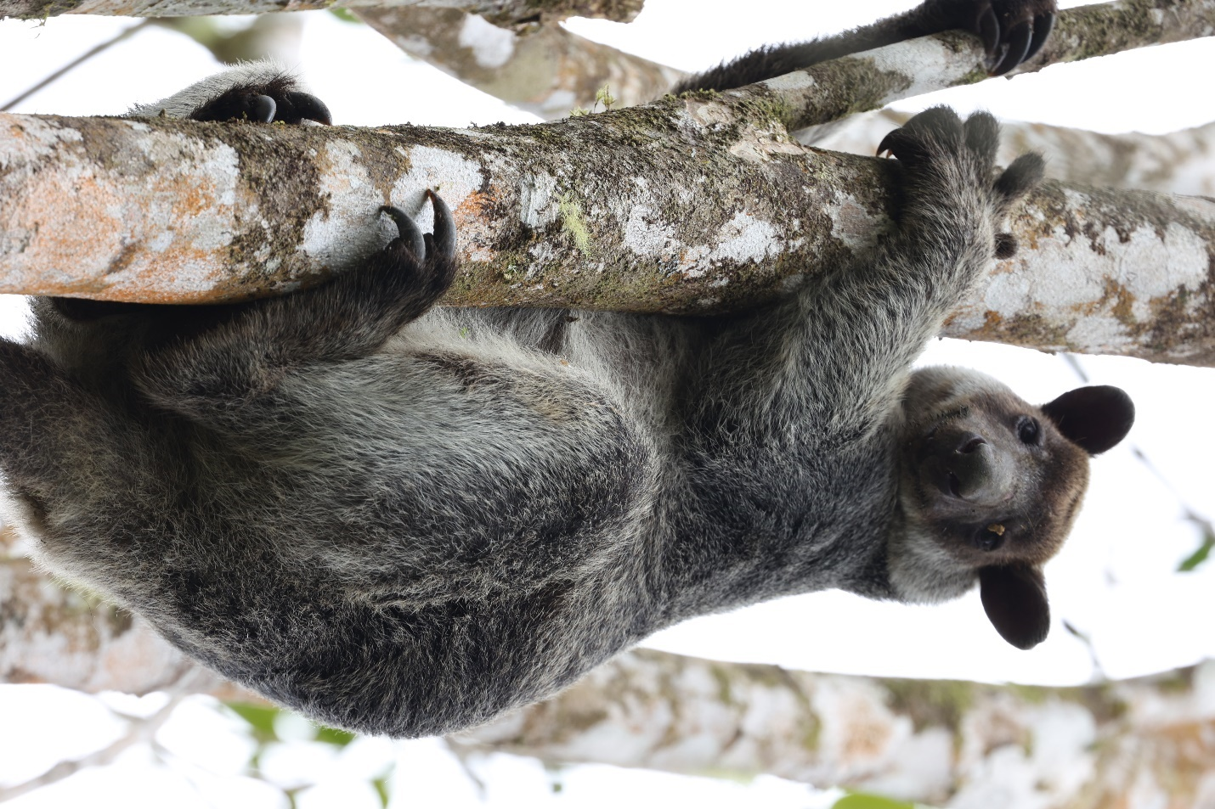
The next morning we were up early, packed and left camp about 7:20 in the morning. Fortunately the day was clear and sunny and we made it to the first river crossing shortly after 9:00 am, which was gratifying as it had taken us four hours from that point to reach camp our first day. However the trail seemed to expand the further we walked and the descent felt surprisingly long and hard. We arrived back at the vehicles about 2:00 pm. A suggestion was made that we stay the night at the Aston Nui and then go on to Han’s village the following day, which was greeted with enthusiasm by members of the group. Rarely has a shave and shower felt so welcome, nor a dinner at Pizza Hut tasted so delicious.
The next morning I rose early, excited by the thought of a breakfast buffet, but was surprised that it consisted largely of chicken and beef stew offerings. A leisurely morning followed, including a lengthy swim in the pool overlooking the ocean. At about 3:30 pm we headed out, picking up Hans and driving through several villages well-known to birdwatchers. By the time we arrived at the trailhead, it was raining heavily so we went back to Han’s place for coffee and a chat with a British botanist from Kew Gardens who was doing fieldwork. By 6:00 pm the rain had stopped and we headed back to the trailhead. We saw two new mammal species, a Stein’s Cuscus and a Miniopterus magnater, which, somewhat confusingly, is perhaps best described as a “big mini”. We also saw five Arfak Ringtail Possums as well as several bats observed previously.
The next morning we were up early to head to the Manokwari airport, a 10 minute drive from the hotel. Security was cursory and we were quickly through to the boarding lounge. After an uneventful flight to Sorong, we were picked up by our new guide, Absalom, and his group, as well as Juliana Senawi, a Malaysian bat biologist who was joining us for the second week of the trip. We stopped for beer and ice cream and then had lunch in a little restaurant. After picking up further groceries, we left by about 1:00 pm and drove to Malagufuk for a brief look at the boardwalk to which we would be returning the following day. My partner had some difficulty believing this was the actual name of the village so my priority was sending her a photo of the village sign as proof before we continued on to another village. Apparently we were the first tourists to visit the village, which occasioned a welcoming ceremony. Two small houses were provided for our use so that we could lay out pads and sleeping bags on the floor. Dinner consisted of the by-now familiar Papuan staples of rice, noodles and veggies, followed by afternoon rain for dessert.
We started hiking about 8:00 pm. Our first new mammal was a Black-tailed Dasyure, a type of antechinus, which provided excellent views. We then saw a Pogonomelomys bruijnii as well as several bats seen previously. We reached a clearing near a small river and did a small circular hike from there. Arriving back at the rest spot, Carlos was holding a Long-fingered Triok. Somewhat surprised by the appearance of this highly desired species we asked how it had been caught. The account provided was that the trioks occasionally feed on seeds on the ground and one of the villagers had been able to approach it and grab it with lights turned off. Given that with the light off I couldn’t see my hand in front of my face, this explanation strained the bounds of credulity, but there was the mammal to prove it. We were all duly impressed. About 11:00 pm, Carlos said “it looks like the echidna isn’t playing ball tonight”. Within minutes the call went out from the villagers deeper in the forest. We scrambled up some steep inclines and eventually found them beside a small creek with a Long-beaked Echidna. This near-mythical animal was as spectacular as I could have ever imagined it might be. It had huge claws and a surprisingly large dangling wedding tackle. Its response to any sort of disturbance appeared to be hiding its head amongst the roots and leaf litter, which probably explains its rarity in a protein-poor environment like New Guinea. We also saw a new rat species while scrambling around the echidna, likely the New Guinea Spiny Ray, Rattus praetor. We watched the echidna for a while then hiked back, tired but elated.
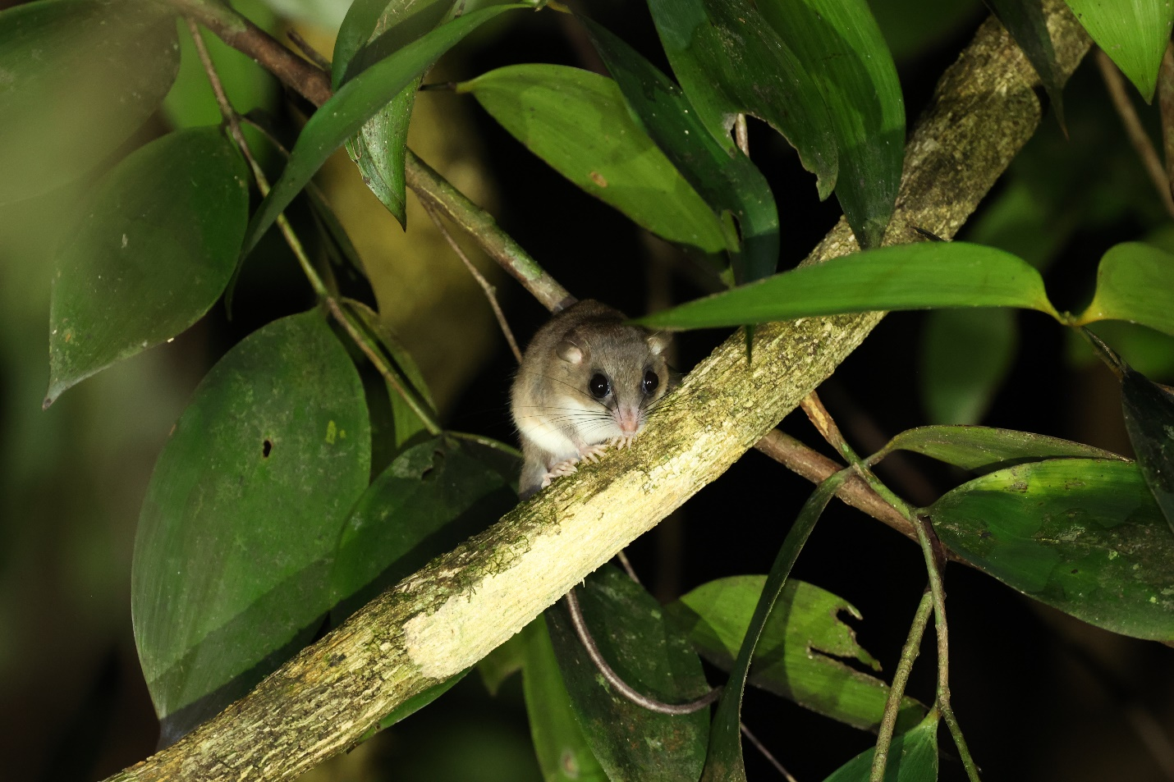
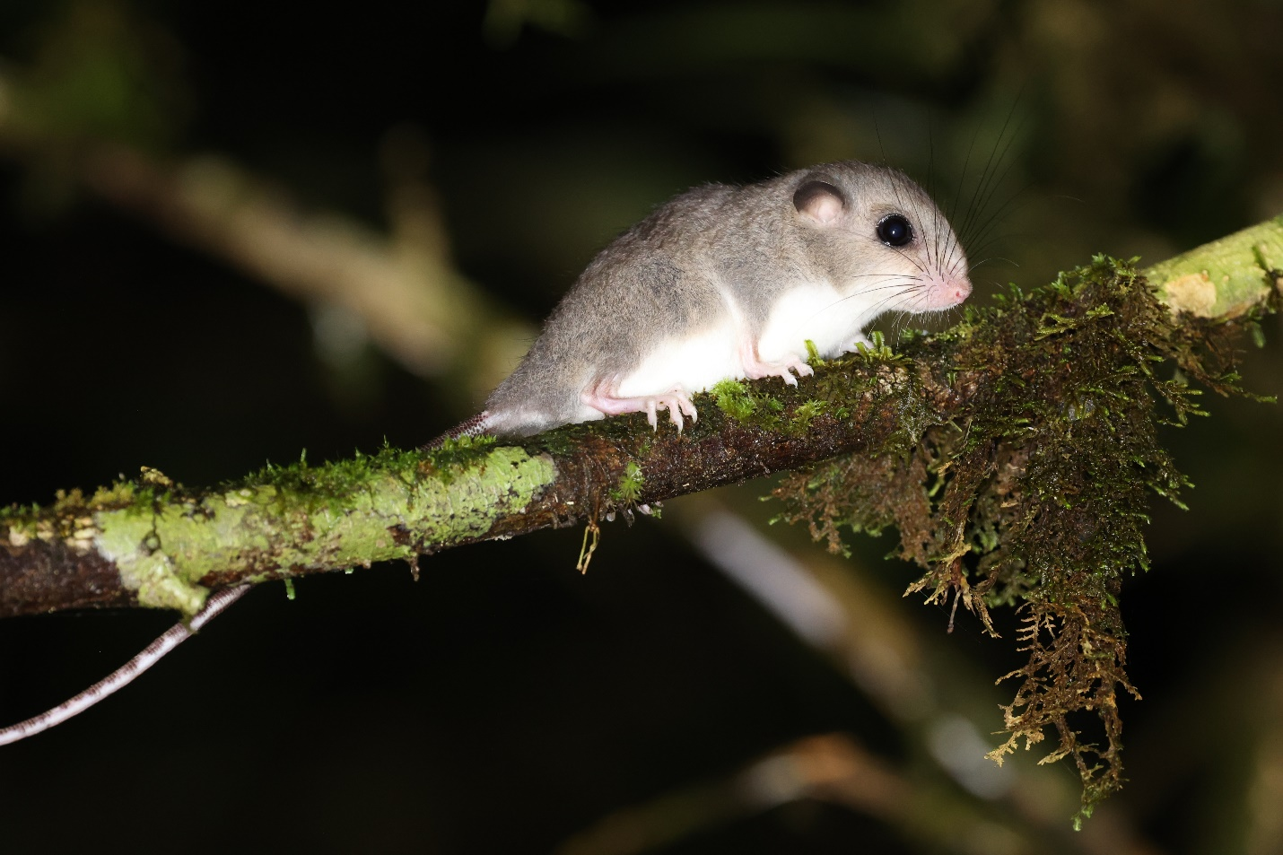
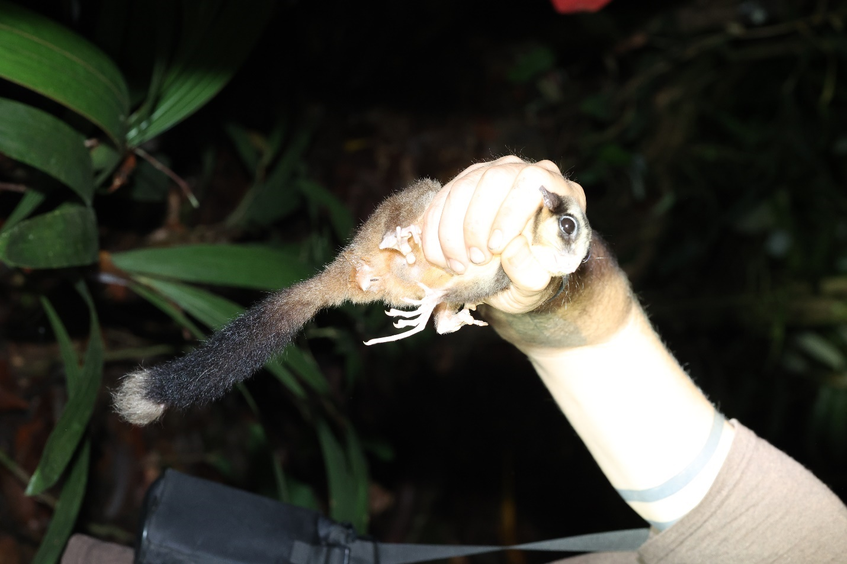

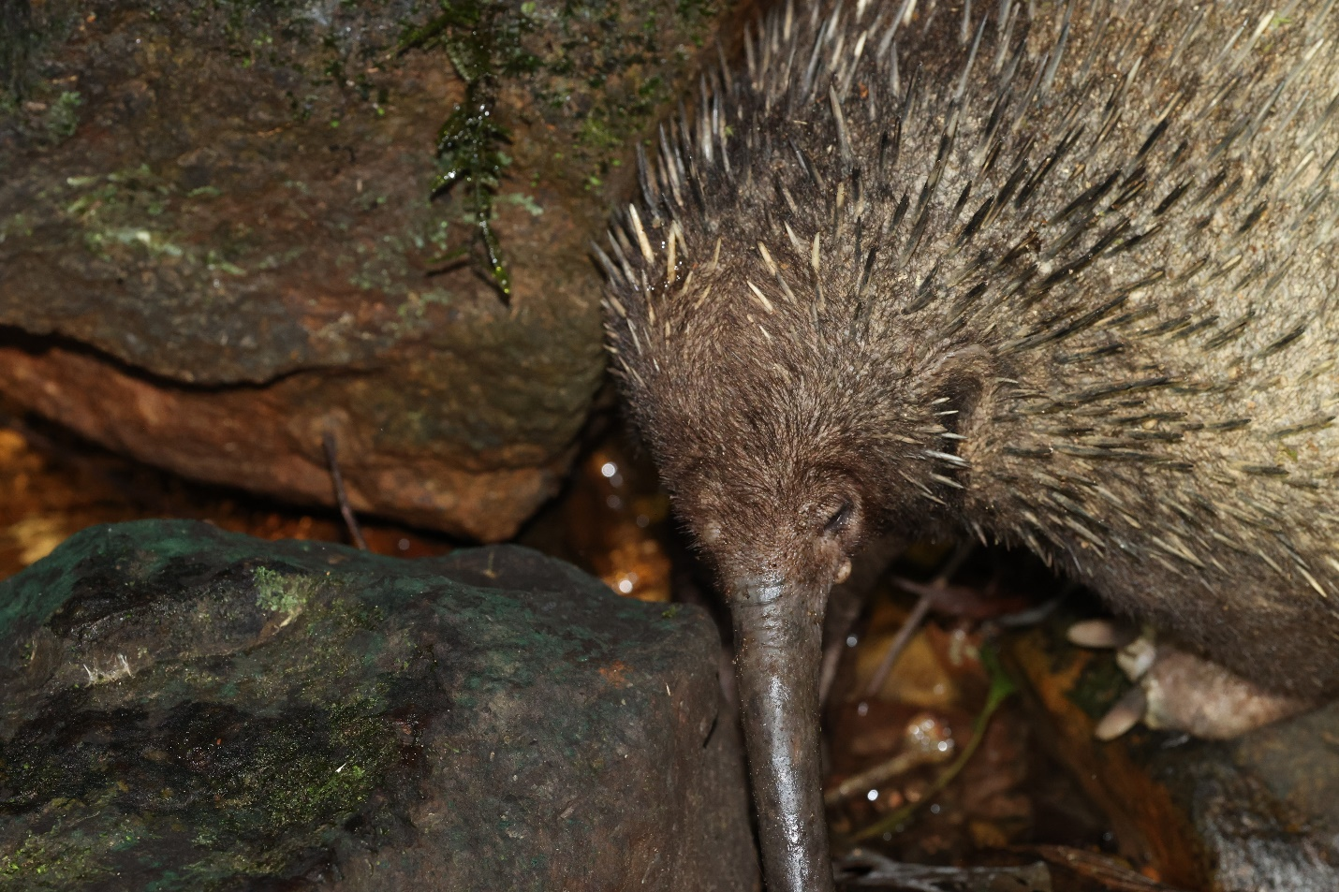

The next morning, Carlos’s 36th birthday, we awoke to a breakfast of hard-boiled eggs with a strange red sauce and some mushrooms. I manage to scavenge a bit of peanut butter for a peanut butter sandwich. At about 11:00 we headed off to a bat cave which was described as being quite close by. An hour later we were told that we still had at least 30 or 40 minutes to go which was unfortunate as we were due to leave the village about 2:00 pm, thus adding to my extensive life list of ultimately futile quests for bat caves. We arrived back for a lunch of fish with greens, rice and noodles. We presented the village with a sizable financial donation in thanks for their protection of local wildlife and then drove through heavy rain back to Malagufuk. Malagufuk is apparently well-known on the West Papuan birding circuit for lowland rain forest species. During the COVID19 pandemic when there were no visitors the government decided to build a boardwalk from the highway to the village. It was remarkable to see a boardwalk of this size and quality in a fairly remote spot. The boardwalk was much appreciated for allowing us to get out of the mud, but turned out to be treacherously slippery when wet, which is essentially 24/7/365 in West Papua. We arrived at the village about 4:30 pm. Our first new mammal of the evening was Great Flying Fox, a number of which have a camp near the village. Dinner consisted of omelettes, rice, noodles with a citrus flavour and eggplant in a soy sauce. The eggplant was a nice addition and we complimented the cook on it, which resulted in us being served eggplant two or three times per day for the remainder of our stay. About 8:15 pm we left for hike, quickly seeing a rat in a tree hollow which was likely Melomys rufescens, a Rakali (water rat) and a Lowland Ringtail. We also saw several Common Spiny Echymipera/Bandicoots around the village. There may well have been other mammals around the village but given that most of what we picked up on the thermal imagers were dogs under buildings or chickens in trees we called it a relatively early night.
I was greeted the next morning by several Papuan (Blyth’s) Hornbills flying around. After breakfast of omelettes and bread we hiked in to a couple of caves, which revealed Biak Roundleaf Bats (Hipposideros papua) in one cave and Bare-backed Fruit Bats or Moluccan Naked-backed Fruit Bat (Dobsonia moluccensis magna) and Raffray’s Sheath-tailed Bat (Emballonura raffrayana) in a second cave. Lunch consisted largely of sardines in tomato sauce which was not a popular meal, given that four people on the trip don’t eat any fish and the two others have profound aversions to sardines. After lunch we walked down the boardwalk about 40 minutes to a lovely clear river for a much appreciated bath. The afternoon, which had been sunny, turned to rain. After a dinner of eggplant and instant noodles, supplemented with newly arrived reinforcements of beer and coke from Sorong, we headed out again. New species for the night included Nyctimenes aello, Pteropus macrotis, Long-footed tree mouse/New Guinea Jumping Mouse (Lorentzimys nouhuysi) and Brown Dorcopsis, as well as previously-seen species such as Lowland Ringtail, Northern Common Cuscus, Striped Possum and Dobsonia magna. The rain gradually picked up and we headed back to the village around 10:00 pm. In a grassy area in the village we came across a two metre-long D’Albertis Python with a spectacular glossy sheen to its skin. Thanks to Jon, we had some access to Internet, including a notification to me that my Monday flight from Sorong to Jakarta had been moved 3 ¼ hours earlier making it unlikely I would be able to arrive back in Sorong from Waigeo on Monday to catch my flight.

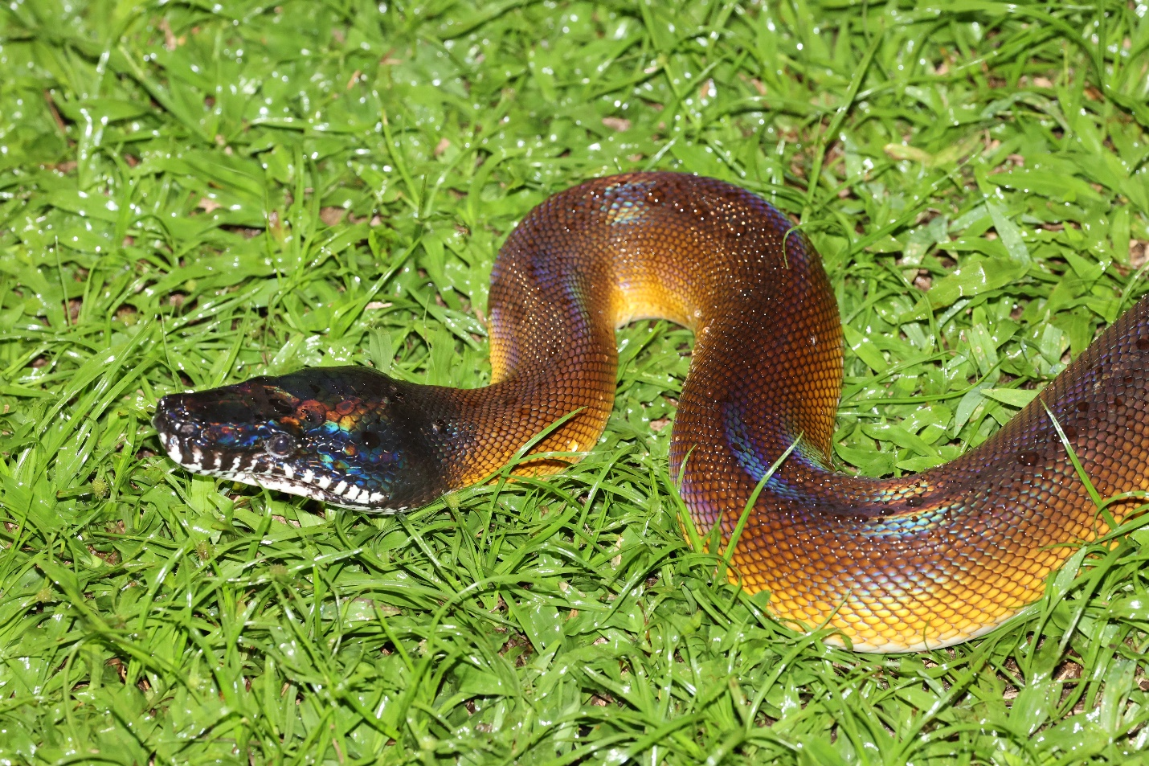
The rain poured incessantly during the night but lessened a little bit in the morning. We left early to hike the boardwalk which revealed a Brown Dorcopsis, two Western Crowned Pigeons walking on the ground near the boardwalk, and then close views of a Three Striped Dasyure, although it was in dark underbrush and hard to photograph. A couple of further Brown Dorcopsis were seen and a Red Bird of Paradise was heard calling. Breakfast consisted of eggs, fried plantain and bread which was starting to go mouldy with some of the remaining peanut butter. The day was exceptionally humid even by West Papua standards and heavy rain started about 11:00 am, continuing through the afternoon. I had the distinct sensation of being trapped in the opening scene of the movie “Indochine.” Lunch, unsurprisingly, consisted of eggplant, rice and water spinach. After supper I went for a walk around the village, the glutinous mud claiming one of my flip-flops as a victim. We had our first definite view of a Long-nosed Echymipera which ran towards us and posed for a good view. We also saw several Common Spiny Echymipera, and a large number of village dogs who appeared completely uninterested in them. A terrestrial rat was seen briefly before it disappeared down a burrow prior to identification. We climbed the trail behind the village on a set of cement steps. We saw a Kerivoula muscina, a new rodent Paramelomys platyops and several previously-seen mammals including a Papuan Glider, several Brown Dorcopsis and a couple of rodents. On the way back, we had a good look at Hipposideros diadema, Emballounoura raffrayana, Nyctimene albiventer and Paronyctimene raptor.
Thanks to the sunrise, roosters and assorted other noises, the next morning started early. Absalom was going into town for supplies and, given that most of the mammal-watching activity in West Papua is nocturnal in nature, I decided to go with him to try to change my Sorong to Jakarta flight. The 3 km trek along the boardwalk was uneventful and we were able to catch a lift in the back of a pickup truck after a brief wait. I spoke with Batik Air but they informed me that they were unable to change my flight as I had booked internationally through a consolidator and switching to another airline, even when they were part of the same company, was impossible. Absalom introduced me to a friend who he said could assist me. He offered me a lift on his motorcycle to a spot to meet up with Absalom for the return journey to Malagufuk. Upon arrival, there was no sign of Absalom and his friend suggested he was likely at the nearby supermarket. Thinking that I might be able to convince Absalom to pick up some different food supplies, we headed over to the supermarket but could find no sign of Absalom there either. We returned back to what I was told was the established meeting spot, a rather nasty and smoky food stall. After waiting fruitlessly for close to an hour and being told by Absalom’s friend that he was not answering his phone, I decided to make my own way back to Malagufuk. When I asked the driver of a pickup truck if he could take me there, he indicated he knew where Malagufuk was and could take me. Perhaps Malagufuk is the only destination along the road east of Sorong that foreign tourists visit. For the hour-and-a-half drive back I was joined in the back by a very pleasant Papuan chap and his son as well as an older gentleman. We were able to carry out a conversation entirely in sign language for the duration of the trip. I arrived back in time to have a brief soak in the river and still make it to the village before dark. We went out on a night walk about 8:00 pm and saw several new species of rodents: White-tailed Giant Rat (Uromys caudimaculatus), Pogonomys loriae and an arboreal rat which Carlos had never seen before as well as some of the usual sightings, Striped Possum, Brown Dorcopsis, Common Spiny Bandicoot and Lowland Ringtail. The most entertaining species of the evening was a small mouse which was able to bounce extraordinarily high relative to its size. One of the guides was eventually able to grab one and we were able to confirm it as a New Guinea Jumping Mouse although well outside of its previously described range. This may well be a new species in the genus.
Our last day in Malagufuk we all slept in a bit. A villager had caught a rat which appeared to be Rattus exulans. Lunch consisted, unsurprisingly, of eggplant, rice, water spinach and green beans with a bit of chicken. The sky cleared a bit in the afternoon and we headed down to the river for a soak, managing to make it back to camp just before the rain started. Is there ever a day when it doesn’t rain in Papua? The heavy rain continued through the evening but lessened at about 8:00 pm. Our evening walk around the village and along the boardwalk revealed only previously-seen species and we called it an early night.

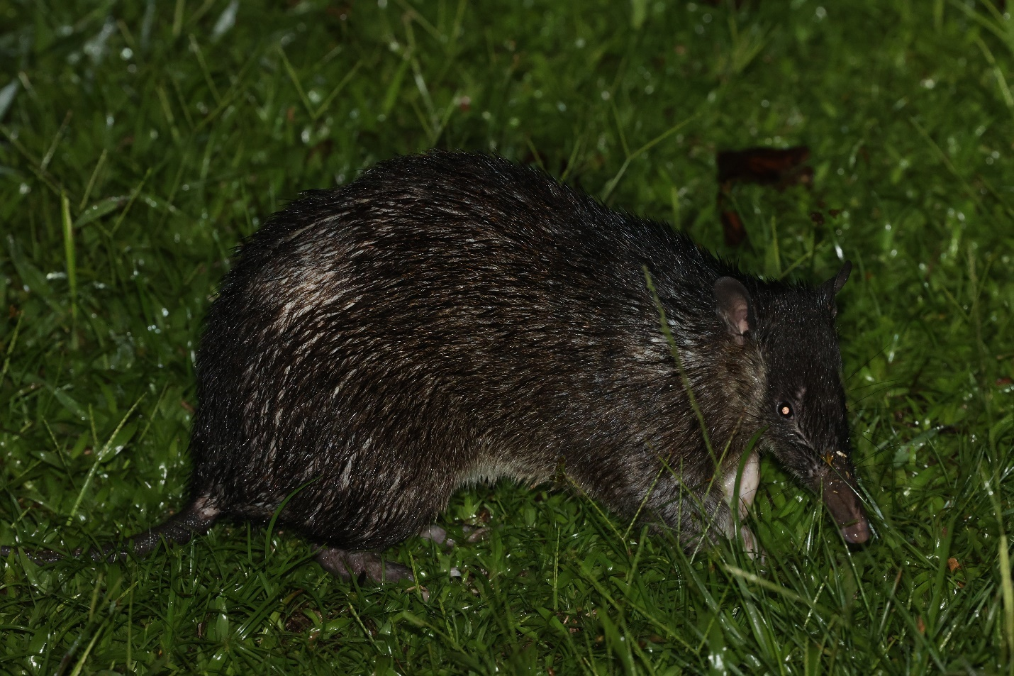
The next morning we packed up and walked back down the boardwalk to the road. I took a picture during a rest break which I texted to Tracey. She commented on how wet it looked, not realizing that the photo had been taken during one of the rare moments when it was not actually raining. For lunch at the Swiss Belhotel I had spicy steak and rice, banana fritters with chocolate and a mango shake. I’m not sure any meal in recent memory has tasted so good. We said bye to Venkat, who had to return to California, and then proceeded to the ferry to catch the boat over to Waigeo, one of the main islands of Raja Ampat (“Four Kings”), a well-known diving location northwest of the main island of New Guinea. The ride over provided views of Bottlenose Dolphin, Melon-headed Whale and Spinner Dolphin. We headed over to the lovely Waiwo Resort, made particularly appealing by the presence of Waigeo Spotted Cuscus in the trees on the hotel grounds. We took a walk down the road by the resort and saw several further cuscus, a Striped Possum, and a variety of bats.
The following morning was lovely and calm. Two pods of Bottlenose Dolphins swam past the resort as I was contemplating the trade-off between spending a couple of weeks at a resort like this versus the last couple of weeks we had actually had. After a delicious breakfast, we drove up a steep road and then did a brief walk to a hide for Wilson’s Bird of Paradise. At first, the bird remained deep in the vegetation. The guide then sprinkled some leaves on the display ground. The bird continued refusing to show until we moved to the second row of seating in the hide. At this point, the bird’s obsessive-compulsive need to clean the display ground overcame the fear of watching spectators, and we were treated to a display by what is often regarded as the world’s most spectacular bird. Afterwards we explored a cave which Carlos had visited previously. A White-tailed Giant Rat (Uromys caudimaculatus) was sitting on a ledge at the far end of the cave, watching us and we observed some Hipposideros papua and Trident Leaf-nosed Bat (Aselliscus tricuspidatus). Afterwards, it was back to the resort for lunch and then time for me to catch the ferry back to Sorong in order to make my flight the following day.
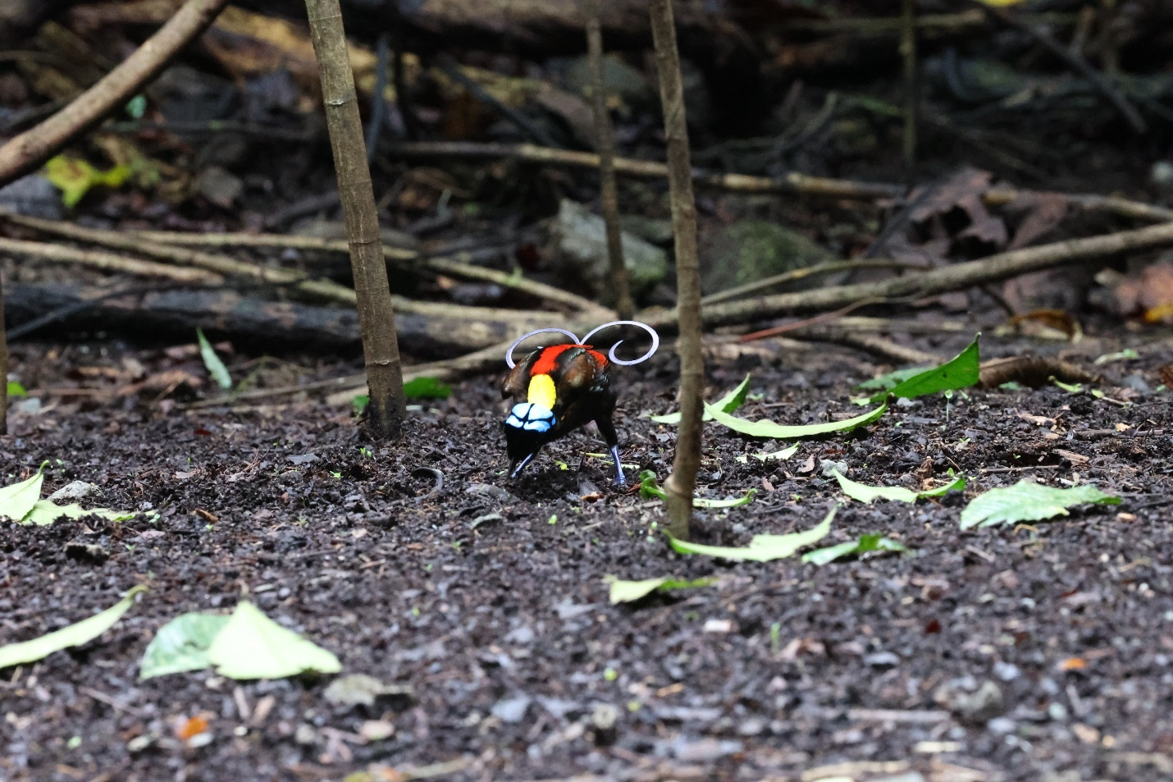

I caught an unexpected bonus on the trip home. Batik Air moved my flight from Sorong even earlier, which gave me a six-and-a-half hour stopover in Makassar, enough time to find a taxi driver to take me to Bantimurung National Park which is less than an hour’s drive from the airport. The park was reasonably busy, but there were no other visitors in the two main caves, Gua Batu, which held a Small Asian Sheath-tailed Bat, and Gua Mimpi, which contained Geoffroy’s Rousette, Diadem Leaf-nosed Bat and Fawn-colored Leaf-nosed Bat. I had to head back to the airport just as dusk was falling, so I wasn’t able to find any Makassar Tarsiers, a terrible miss which I will try to rectify on my next trip to Sulawesi. I bumped into Charles and Juliana at the airport, who told me I probably could have caught the flight from Sorong even if I had taken the ferry that morning. Such is life.
As I write this report, memories of the trip are flooding back. Carlos, a chain-smoking bon vivant with boundless energy and enthusiasm, creating a trip for the ages. Juliana, calm and patient bat-expert extraordinaire. Group members wandering through the forest at night, scrambling around to see hidden bits of creatures’ anatomy and debating Latin names. The omnipresent heat, rain and humidity. The profusion of rare and poorly-known mammal species. The monotony of the food. The skills and enthusiasm of the local guides. Huge thanks to Carlos, Juliana, Jon, Charles, Venkat, Nils, Hans and Absalom for their camaraderie. Not the easiest trip ever, but certainly one of the most memorable.
Sulawesi – Mammal Species seen:
Heck’s Macaque (Macaca hecki)
North Sulawesi Babirusa (Babyrousa celebensis)
Sulawesi Warty Pig (Sus celebensis)
Black Rat (Rattus rattus)
Geoffroy’s Rousette (Rousettus amplexicaudatus)
Small Asian Sheath-tailed Bat (Emballonura alecto)
Diadem Leaf-nosed Bat (Hipposideros diadema)
Fawn-colored Leaf-nosed Bat (Hipposideros cervinus)

West Papua - Mammal Species seen (some species still to be clarified):
Western Long-beaked Echidna (Zaglossus bruijnii)
Müller’s Three-striped Dasyure (Myoictis melas)
Black-tailed Dasyure (Murexia melanurus)
Raffray’s Bandicoot (Peroryctes raffrayana)
Common Echymipera (Echymipera kalubu)
Long-nosed Echymipera (E.rufescens)
Ground Cuscus (Phalanger gymnotis)
Northern Common Cuscus (P. orientalis)
Stein’s Cuscus (P. vestitus)
Waigeo Cuscus (Spilocuscus papuensis)
Lowland Ringtail (Pseudochirulus canescens)
Arfak Ringtail (P. schlegelii)
D’Albertis’s Ringtail (Pseudochirops albertisii)
Reclusive Ringtail (P. coronatus)
Long-fingered Triok (Dactylopsila palpator)
Striped Possum (D. trivirgata)
Papuan Glider (Petaurus papuanus)
Feather-tailed Possum (Distoechurus pennatus)
Brown Dorcopsis (Dorcopsis muelleri)
Grizzled Tree Kangaroo (Dendrolagus inustus)
Vogelkop (Black or Ursine) Tree Kangaroo (D. ursinus)
Broad-headed Tree Mouse (Chiruromys lamia)
Common Water Rat (Hydromys chrysogaster)
Long-footed Tree Mouse (Lorentzimys nouhuysii)
Black-tailed Melomys (Melomys rufescens)
Common Lowland Paramelomys (Paramelomys platyops)
Bruijn’s Pogonomelomys (Pogonomelomys bruijnii)
Loria’s Pogonomys (Pogonomys loriae)
Chestnut Tree Mouse (P. macrourus)
Gray-bellied Tree Mouse (P. sylvestris)
White-tailed Giant Rat (Uromys caudimaculatus)
Polynesian Rat (Rattus exulans)
Large Spiny Rat (R. praetor)
Geoffroy’s Rousette (Rousettus amplexicaudatus)
Dagger-toothed Long-nosed Fruit Bat (Macroglossus minimus)
Common Blossom Bat (Syconycteris australis)
Lesser Bare-backed Fruit Bat (Dobsonia minor)
Moluccan Naked-backed Fruit Bat (D. moluccensis)
Unstriped Tube-nosed Bat (Paranyctimene raptor)
Greater Tube-nosed Bat (Nyctimene aello)
Common Tube-nosed Bat (N. albiventer)
Round-eared Tube-nosed Bat (N. cyclotis)
Large-eared Flying Fox (Pteropus macrotis)
Great Flying Fox (P. neohibernicus)
Trident Leaf-nosed Bat (Aselliscus tricuspidatus)
Fawn-colored Leaf-nosed Bat (Hipposideros cervinus)
Diadem Leaf-nosed Bat (H. diadema)
Maggie Taylor’s Leaf-nosed Bat (H. maggietaylorae)
Biak Leaf-nosed Bat (H. papua)
New Guinea Horseshoe Bat (Rhinolophus euryotis)
Raffray’s Sheath-tailed Bat (Emballonura raffrayana)
Lesser Sheath-tailed Bat (Mosia nigrescens)
Little Long-fingered Bat (Miniopterus australis)
Small Melanesian Bent-winged Bat (M. macrocneme)
Fly River Woolly Bat (Kerivoula muscina)
Maluku Myotis (Myotis moluccarum cf. adversus)
Spinner Dolphin (Stenella longirostris)
Indo-pacific Bottlenose Dolphin (Tursiops aduncus)
Melon-headed Whale (Peponocephala electra)

Ian Thompson
Victoria, B.C.
ibtson@yahoo.com

