**Svalbard and northern Norway - Klil Zaitlin**

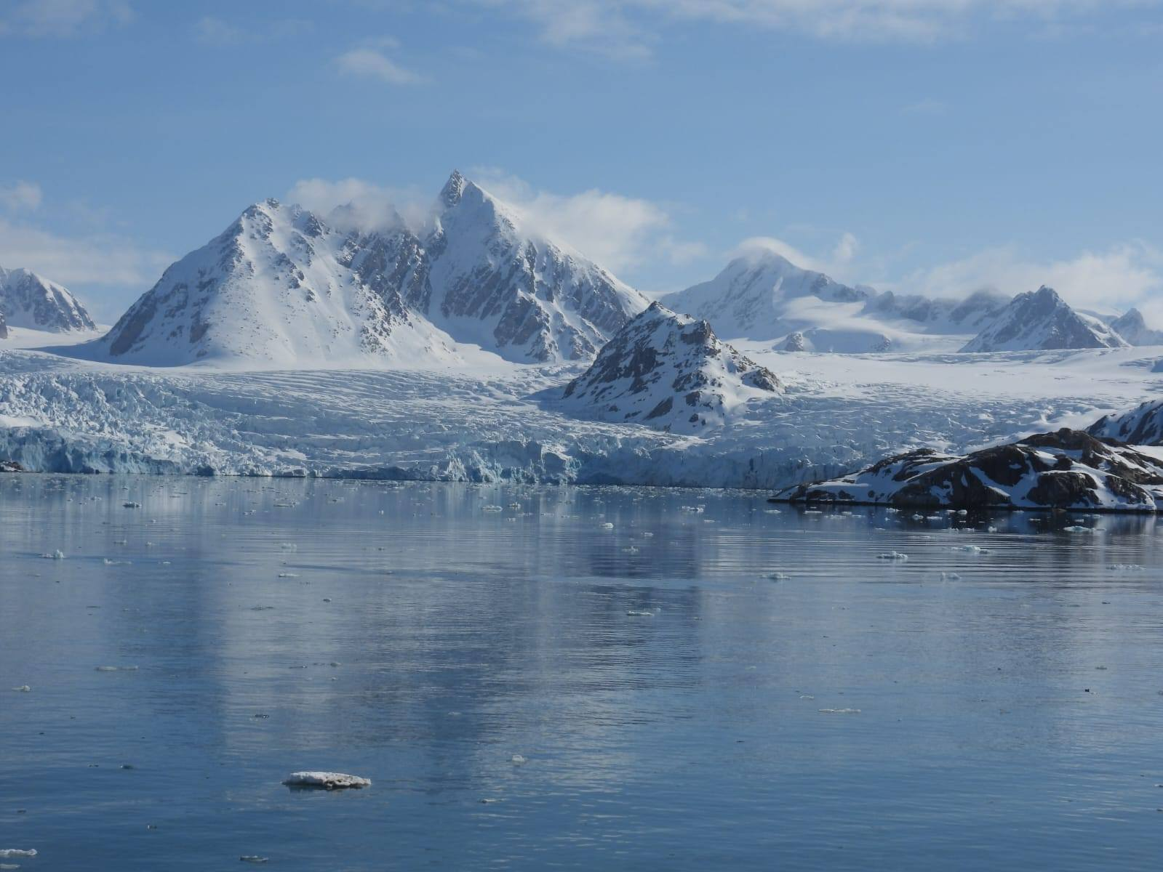

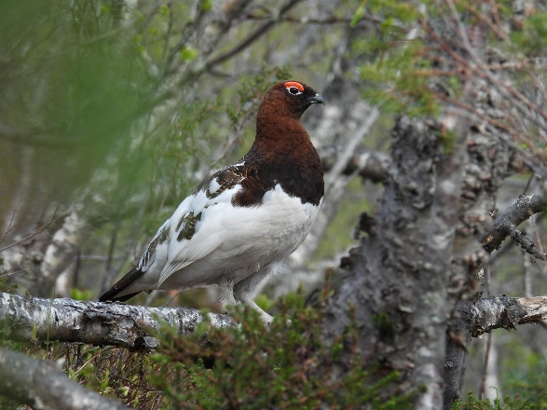**May 30th** - We (me and my father Avner) landed in the late evening in Tromso to a bright and sunny sky. The city looked beautiful, so we had to take a little stroll after a long day of flights. Along the beach we saw our first few birds including curlew, temminck's stint and red throated loon.

**May 31st** - We woke up early and observed the city from the reception of the Moxy hotel on the 11th floor, we were surprised to find two white-beaked dolphins swimming in the fjord about 1km west of the city. Later that day, we went around the city looking for birds. Our highlights were a willow ptarmigan, two woodcocks, iceland gull and glaucous gull.

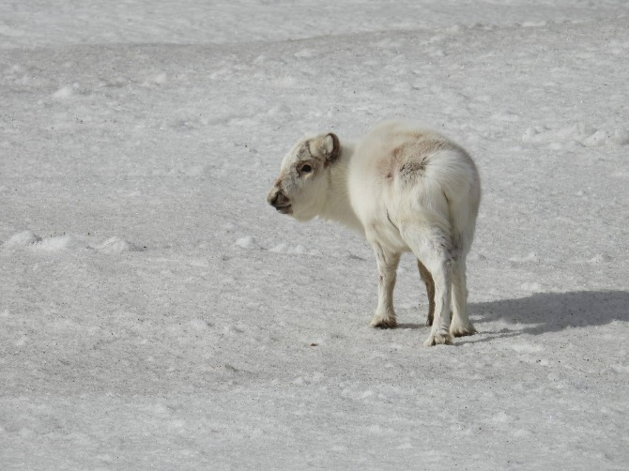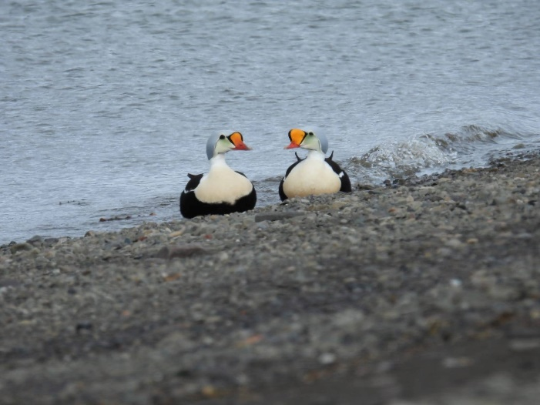**June 1st** - Time for the real thing - Svalbard! We took a flight in the morning and had a full day in Longyearbyen. Reindeers were friendly and gave some close sightings. Apart from that, 3 male king eiders were seen on the beach, a few rock ptarmigans and lots of dovekies on the way to the cemetery and no sign of an arctic fox.

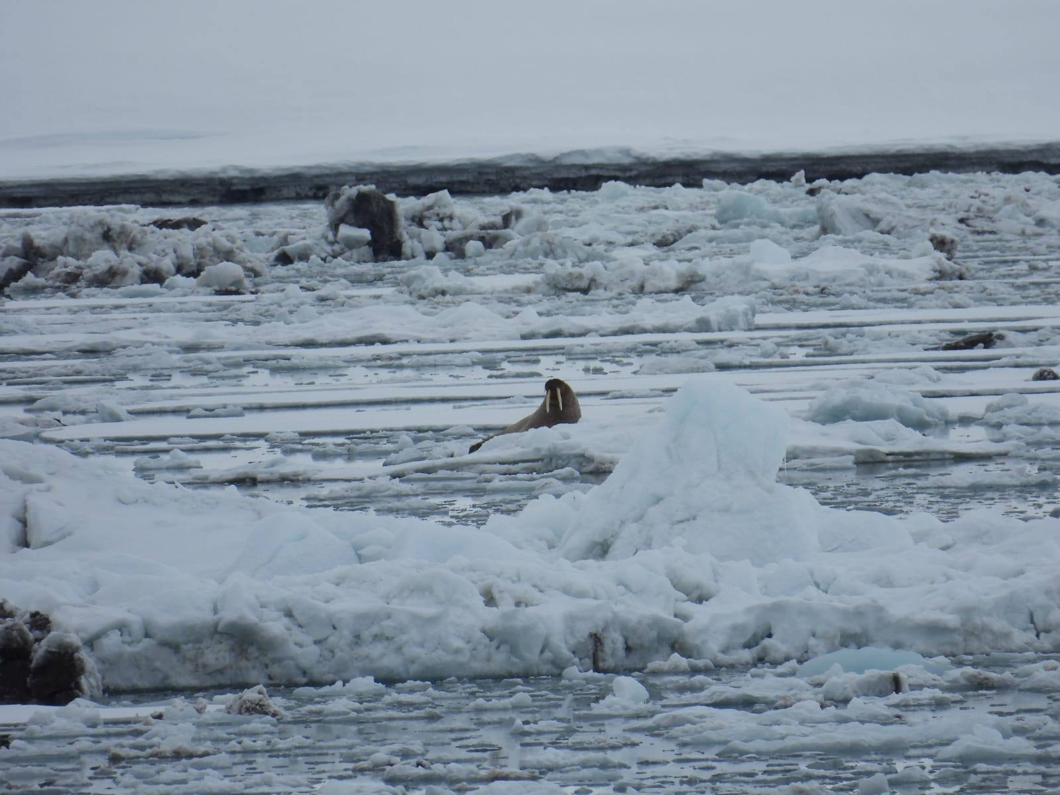**June 2nd** – We embarked onboard the MS Serenissima to a mini cruise along the west coast of Svalbard all the way to Mofin island in the north and back to Longyearbyen - Three nights and less than three days of sailing. We knew it wasn't the best cruise for wildlife, but it was relatively cheap, and we thought that with enough time on deck it would be just fine. The first afternoon of sailing was in the Isfjord and we saw our first walrus and bearded seal. At night the ship went into the open sea, the waves were strong, and seasickness took us early to bed.

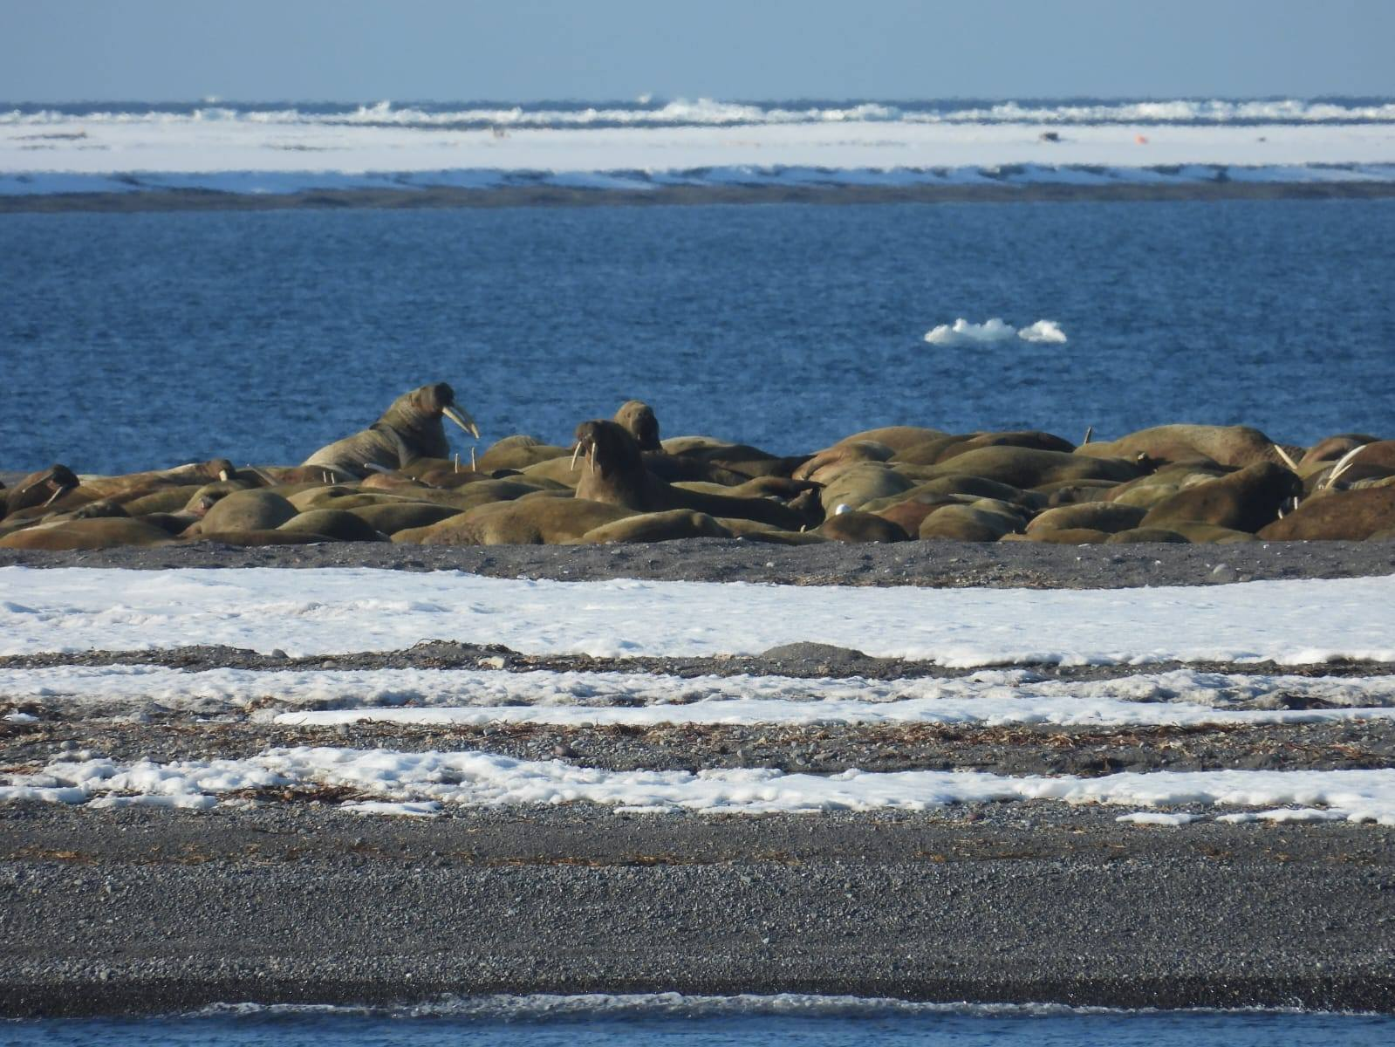

**June 3rd** - It was a sunny morning, and we were already in Magdalenafjord in northwest Spitzbergen. Entering the fjord, we saw our first minke whale that swam along the ship and disappeared very quickly. Inside the fjord we saw our first and last(!) ringed seal for the trip. We moved to a nearby fjord called "the fjord of the bear", which was extraordinary and provided us with good sightings of bearded seals and walruses during the zodiac tour near the glaciers.

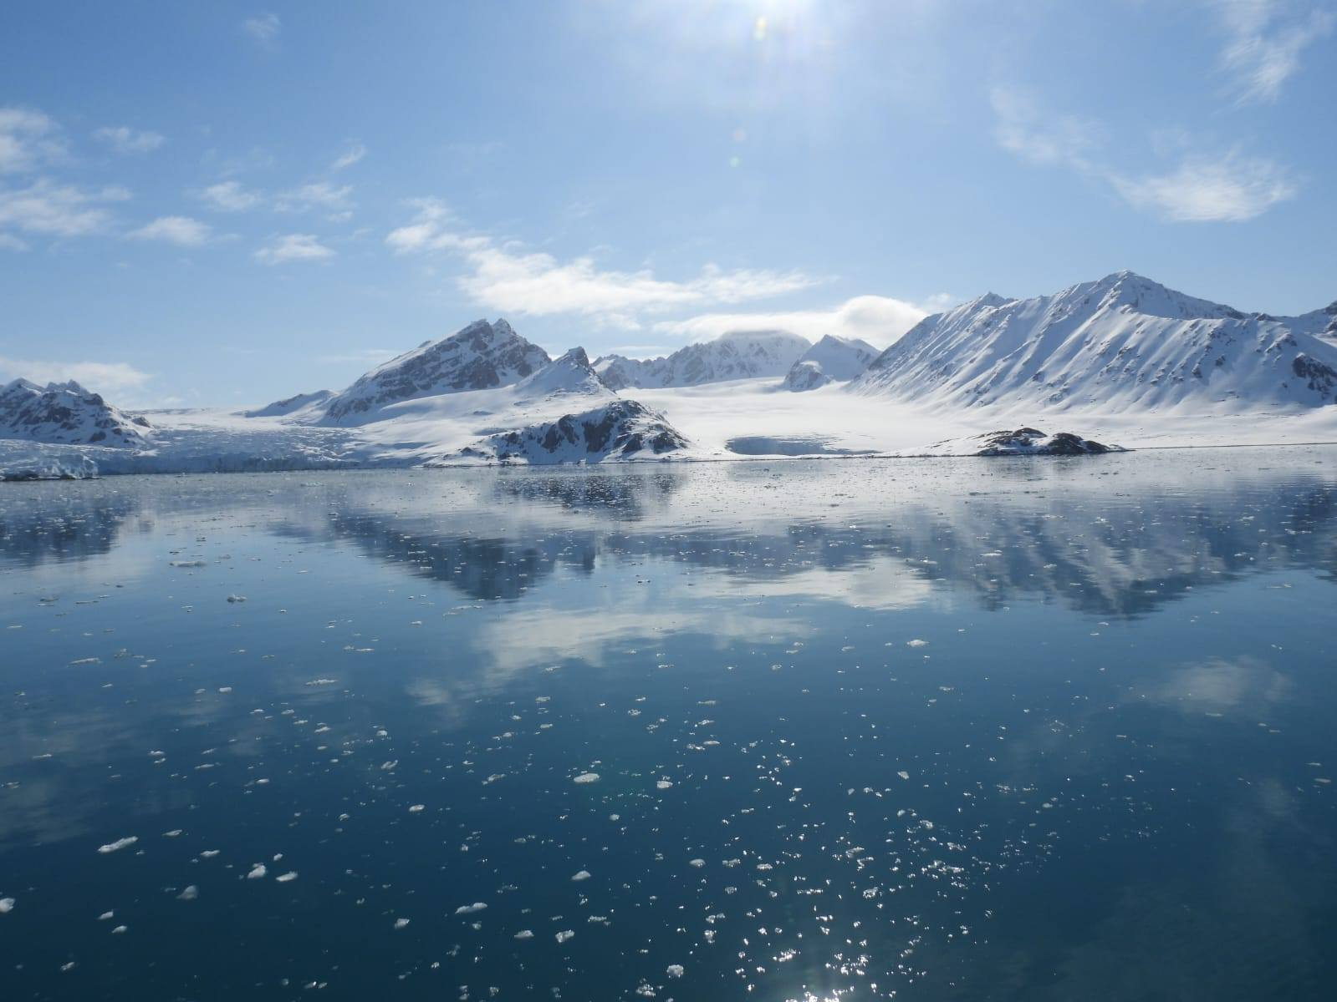In the late evening, we were a bit surprised already from the very little efforts that were made by the guides or any other traveler on the ship to spot wildlife. Moreover, the landings and activities took almost the whole day and we actually spent almost the whole day stuck in two specific places without many animals around them. It was a bit disappointing, but we were eager to try and find something good. So, we were in the front deck as the ship sailed north towards Mofin island. We found one more minke whale and one small whale very far that was possibly a lone pilot whale? and a few more walruses on far glaciers. The highlight of the day was in Mofin island where we observed from a safe distance a colony of walruses.

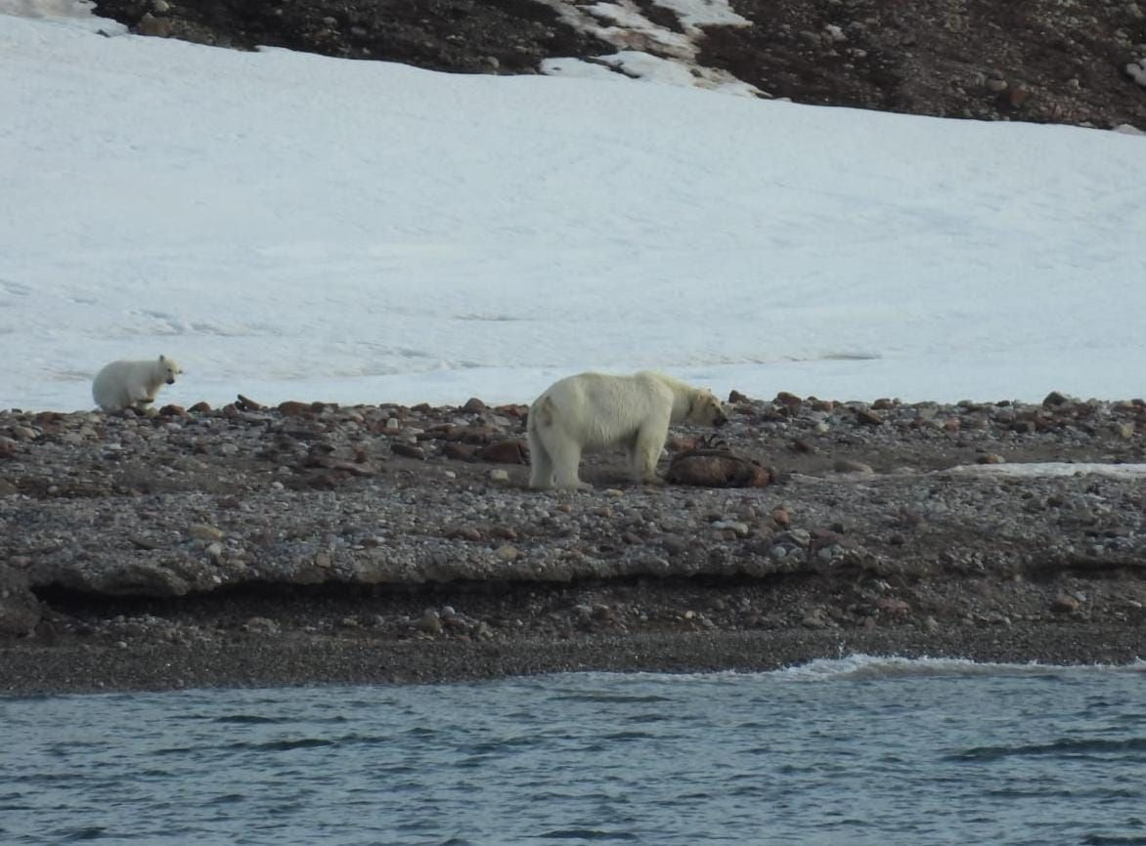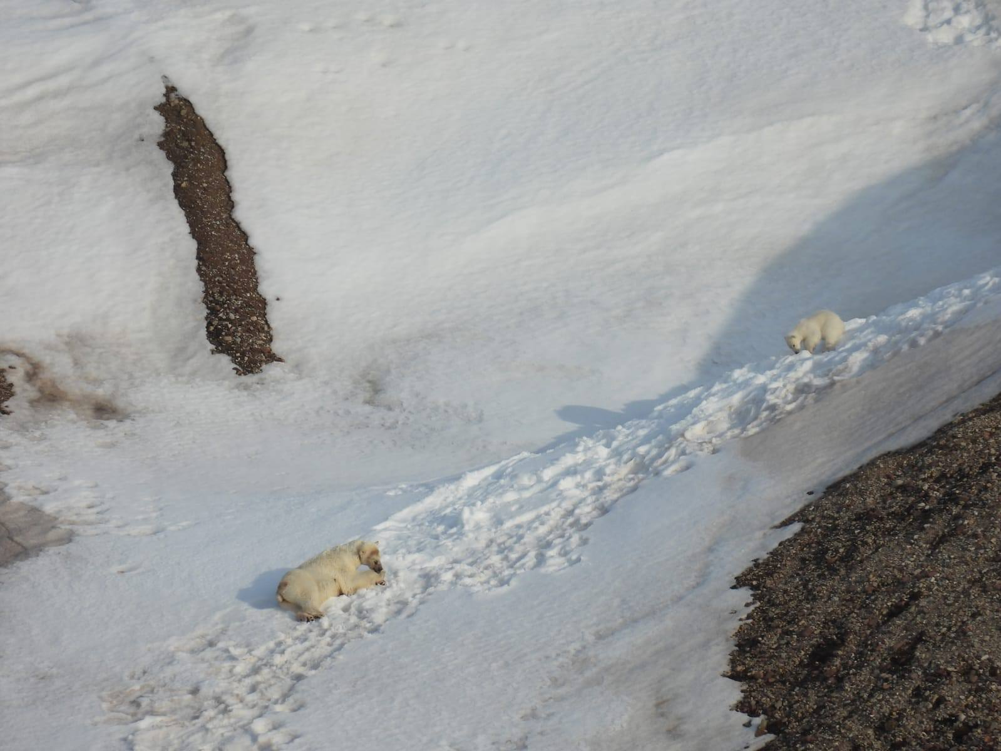**June 4th** - It was our last day to try and find something unique and we were out on the front deck again for the mission. We were stuck the whole day around one place which wasn't particularly good for animals and that was called New Britain. We saw some nice birds like the long tailed skua and a yellow billed loon, but mammals were nowhere around, apart from a few more walruses and reindeers and a very far minke whale. Late in the evening when we almost lost hope, we stopped in the town of Ne Aulsend. The researchers gave our guides a very useful tip and when leaving Ne Aulsend back north we saw all the guides scanning the left side of the fjord. We knew there was something going on and we started to scan the beach. After a minute I thought I could hear the words polar bear, and then I saw it, a large female was standing on the shore far away, but we were sailing in her direction. Getting closer, I suddenly noticed a cub playing in the snow above her. It was an unforgettable sight of the mother and the cub eating a seal and then laying on the snow, that got everyone onboard super excited, and changed the whole trip.

**June 5th** - After breakfast we disembarked from the ship and had another full day in Longyearbyen. We spent most of the day scanning the sea seeing nothing special. but in the evening, we were on a mission - time for the arctic fox. Our idea was to go the furthest corner of the town - where the Huset restaurant is located, sit and wait until no people are around, scanning the cliffs and hope it shows up. It was around 1.5 hours into our weird plan when I got tired of scanning, but suddenly the arctic fox showed up just in front of me and started walking slowly to the other side of the valley and then straight into the town. We followed him, lost him for maybe five minutes and then relocated him eating a pink footed goose he just hunted!

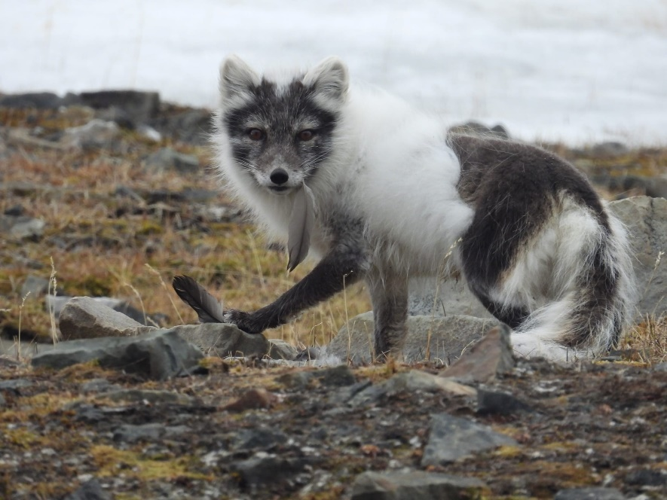

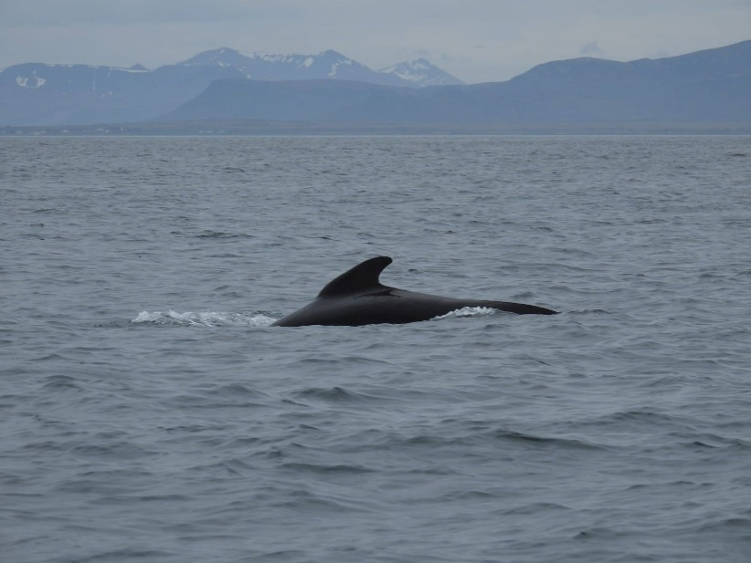**June 6th** - after so many hours of useless scanning, on Friday morning luck finally arrived when we observed a Hugh fin whale swimming in the fjord in front of the city bay. We flew back to Tromso and went on a long drive to Finnsens.

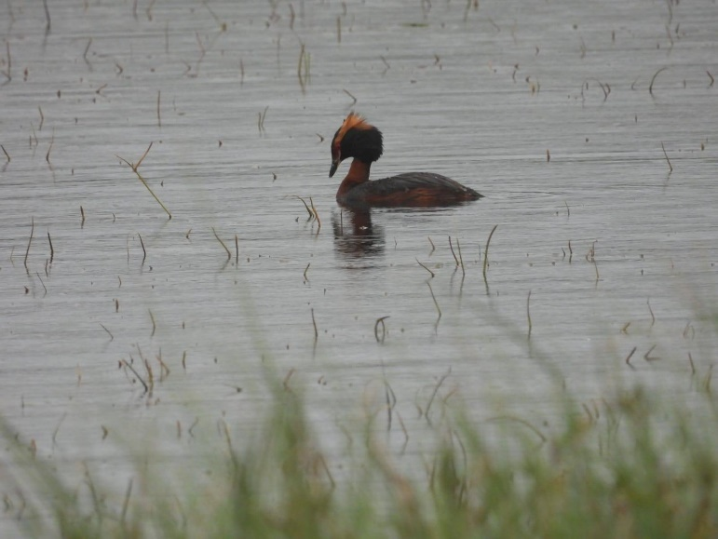**June 7th** - we drove through the amazing Senja island to Gryllefjord where we should catch our ferry to Andenes. Reindeers were seen here and there along the road and mountain hares (some of them still had a beautiful white color) were particularly common in the central part of Senja where there were many forests. We searched some side roads for moose with no luck, even though it seemed like a good area, because we saw lots of signs indicating their presence in the area. The line to board the ferry to Andenes with a car was too long, so we had to leave our car behind. From the ferry we saw another minke whale. From Andenes we went on a rib boat tour in search of whales. They use sound machines to locate the whales, which worked like magic. Within ten minutes we were surrounded by a magnificent group of pilot whales. We were excited because we didn't expect to see this species, and it was the most fabulous observation we had on any kind of whale. Apart from that we couldn't find any other whales, perhaps they avoided the pilot whales. In Andenes we saw a few horned grebes in a small lake.

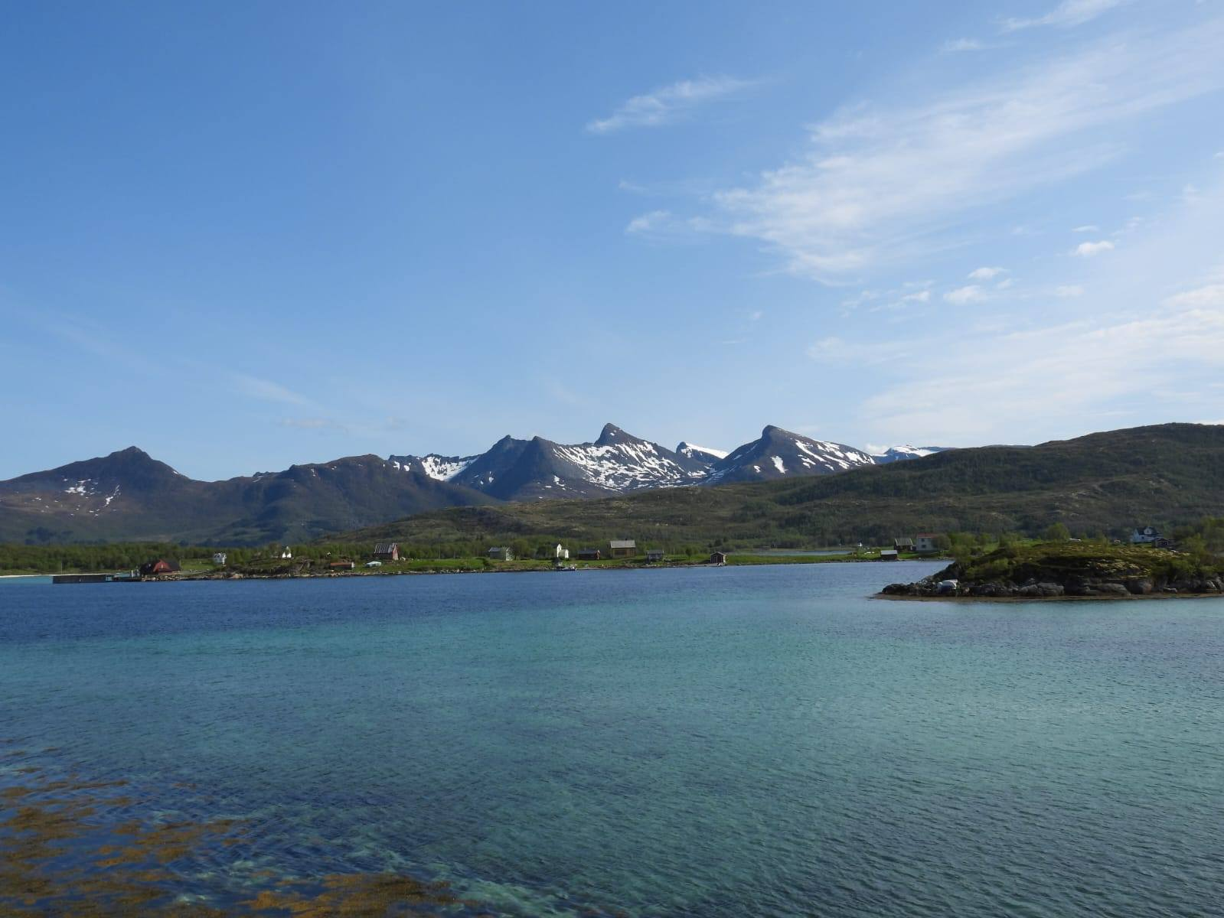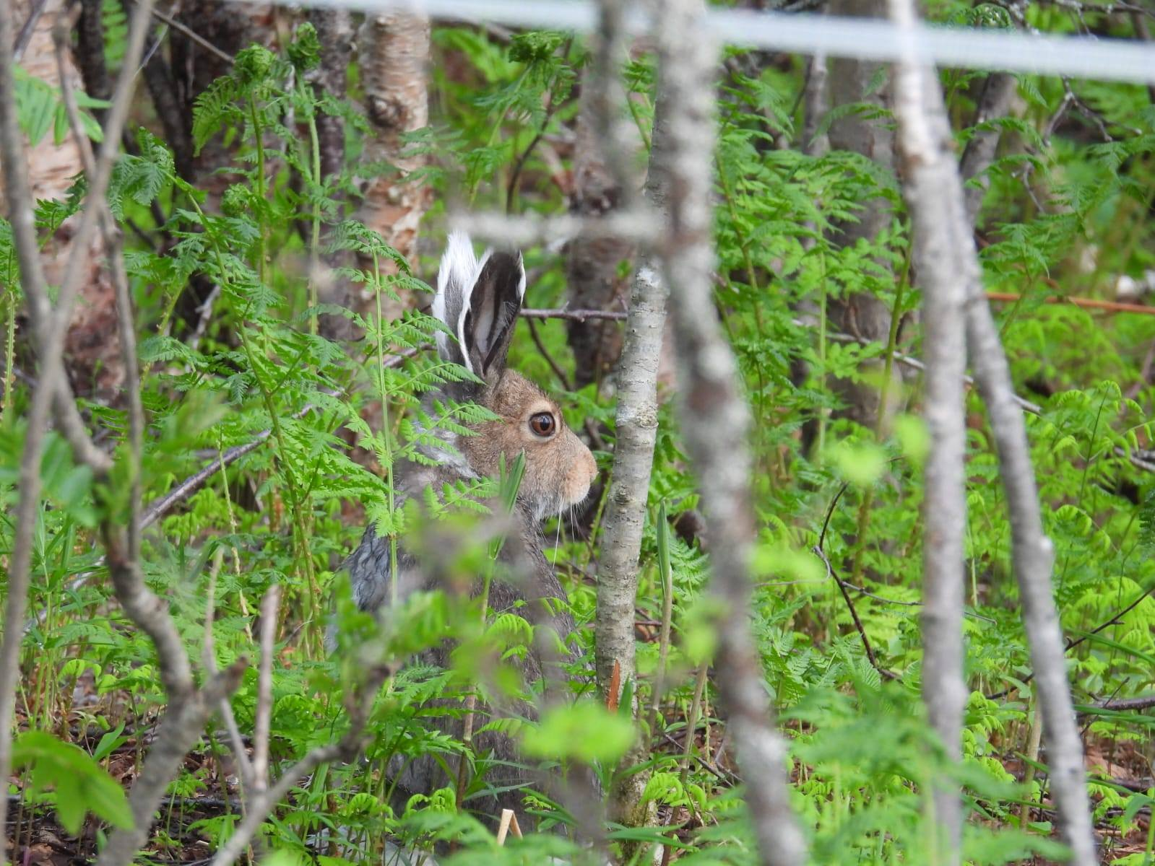

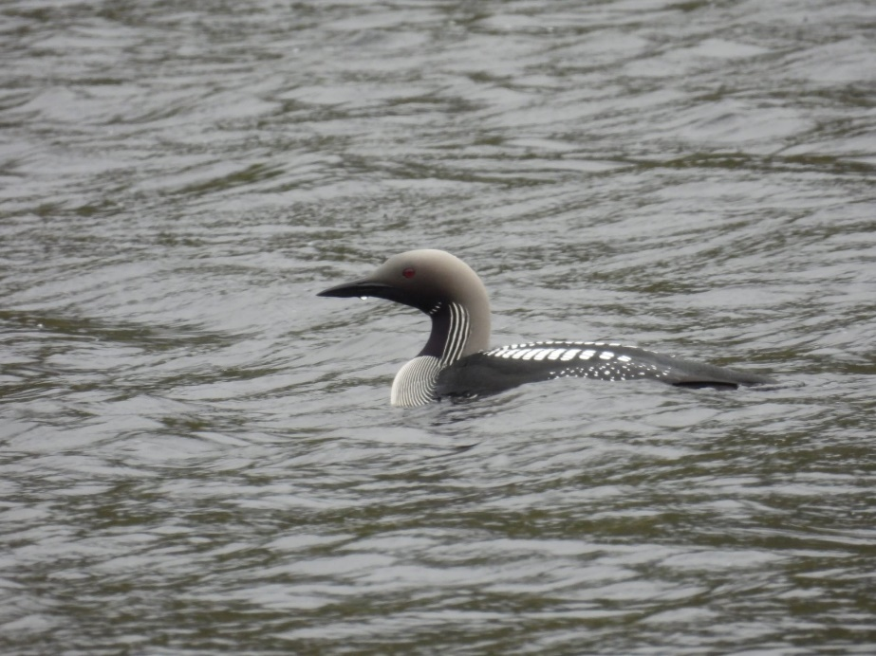**June 8th** - It is our last day in Norway, and for the first time science we arrived it was raining a lot. I woke up early and walked along the eastern coast of Andenes in search of otters. It was exactly at the time that I decided the rain was too strong and it's time to quit when an otter ran through shore in front of me straight into the sea. Trying to relocate it seemed impossible, but I decided to jump between the sea rocks to where I thought it should be. After less than five minutes, with both my socks and my gloves becoming soaked, a weird head popped out from the sea. I think no one was ever so disappointed to see a harbor seal! Well… I wanted to see the otter... The seal went back inside the water and then it was just me soaking wet and freezing, with no seal and no otter.

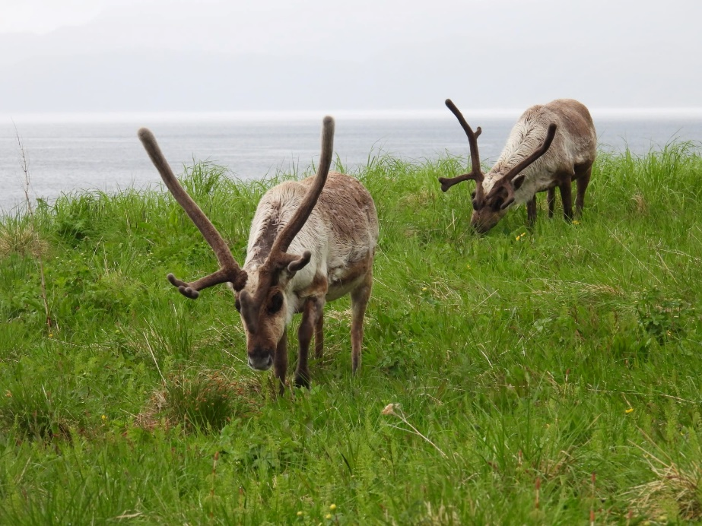After that morning, I had to switch on my sandals, that weren't adjusted to the weather. We took the ferry back to Gryllefjord, and just outside Gryllefjord another otter crossed the road right in front of us and disappeared into the fjord. My father was now happy that he chose to skip the morning walk. It was raining for the rest of the day, and we had just one target species - moose. We tried many different back roads on the way to Tromso until we had to just give up. At least we saw some nice birds along the way – arctic loon in Hella, black grouse in Kaldfjord and a weird looking willow ptarmigan near Tisnes. And that's it, another great trip with many unique encounters and amazing landscapes, and a few uncompleted tasks for next time.