As part of The Big Cat Year we made a visit to Sierra de Andujar in Spain especially in search of the Iberian Lynx. We were successful as we had 4 observations of which 2 far away in open terrain, 1 crossing the road and 1 at the famous hide of Gato Glavo.
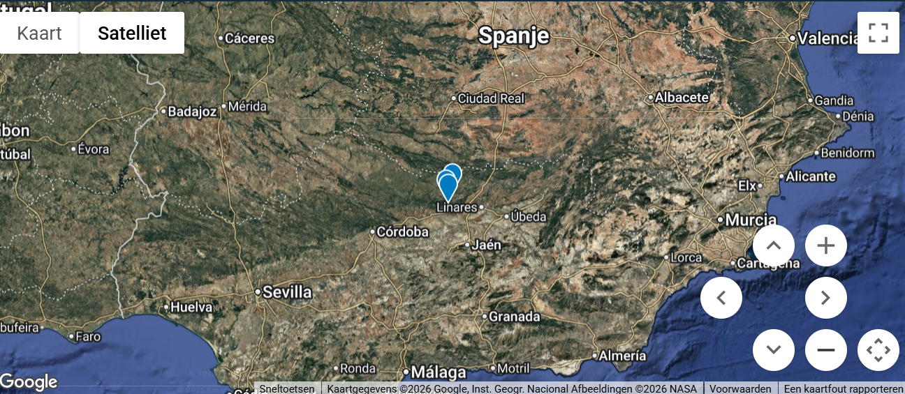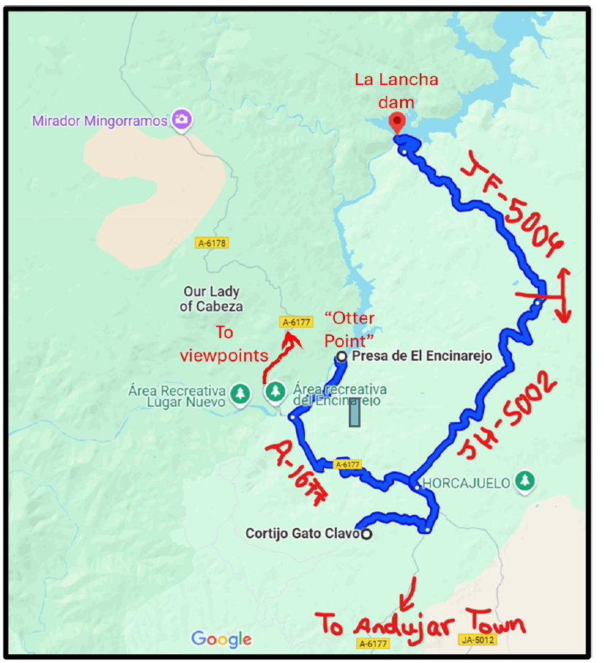
The trip reports on mammalwatching.com were extremely useful. The drawing in the report by Tomer Ben-Yehuda was simple but very useful (shown on the right). Especially the area around the JF-5004 and towards and at the La Lancha Dam was very good. We also visited the ‘Otter Point’ but unfortunately we were not able to spot the otter family which is very often seen around that area. We also missed out on the Mouflons which are seen often the last km or so towards the La Lancha Dam on the left and right side of the road on the other mountainsides. Next to the Iberian Lynx, we managed to see foxes (3x), many Red and Fallow Deer, European Rabbits and a few Iberian Ibex. Birding was oke but not great, interesting birds being Little Bittern, Iberian Grey Shrike and Iberian Green Woodpecker. The Wall Creeper can often be seen at the steep cliffs directly left from the La Lancha dam but we missed it.
Highlights were obviously the sightings of the Iberian Lynx which is described hereafter.
What a great way to start the Big Cat Year with a visit to Sierra de Andujar, the stronghold for the Iberian Lynx. We finished 2025 with our family and friends in Moraira in the south east of Spain and had a great time. But the 1st of January was there and the Big Year really kicked off! After 6 hours of driving we arrived at Sierra de Andujar where we stayed for 4 nights at Gato Clavo, https://www.gatoclavo.com/. One of the few places in Spain where there is a hide especially focusing at the Iberian Lynx. Very well organized with a great passion for nature. Antonio Rodriguez was extremely helpful in getting it all organized and also helped me with some other questions I had with regard to the conservation of the Iberian lynx and its habit in Spain. In addition, it was a real pleasure to have a long talk with local guide

Thomas who explained a lot about Sierra de Andujar, its habitat, wildlife and the behavior as well as the status of the Iberian Lynx.
For your info, around 2000 there were only about 100 to 150 individuals left and it was listed by the IUCN, https://www.catsg.org/ , as critically endangered, i.e. due to several factors it was on the path to extinction! 25 years later and with a lot effort, energy, time, funds and hard work by lots of different parties, there currently are around 2500 individuals in a lot of different populations! One of the remarkable comeback stories by wildlife species which would have gone extinct otherwise.
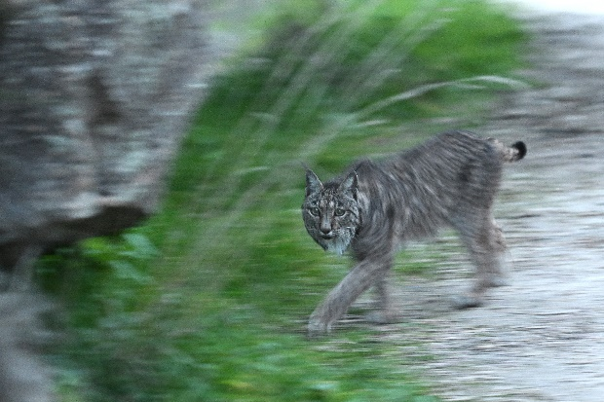
But back to Andujar! As I had one day in the hide at the 4th of January, we spend the 2nd and the 3rd in Sierra de Andujar trying to spot this amazing wild cat. I checked a lot of trip reports on forehand, on https://www.mammalwatching.com/ , so I knew where to be and especially the JF-5004 towards the La Lancha dam proved to be very successful. Already on the 2nd we had two sightings in open terrain but very far away. But we saw it, so it was a great start of the Big Cat Year!! But obviously, we strived for a better sighting and we did the next day. Early morning just before sunrise, around 7:15 we saw one cat strolling beside the road and after a minute it passed the road and it gave the opportunity to make some photographs. Due to the poor light almost all of the pictures were very bad, except for one! Just as it passed the road towards the other side and before moving behind some very rocks, it looked at me and I managed to get a good picture! Just 5 meters away!! A bizarre and magnificent feeling!! Really happy, also as my partner and wife Bea was with me and witnessed it as well. Well done Bea and thanks for the great support!!
The 4th of January was the day in the hide we spend time from 7:30 tot 11:00 AM and then from 15:00 PM tot 19:00 PM. The lynx, a young female, passed the hide once, some time after 17:00 PM and gave great views! What a cat!!
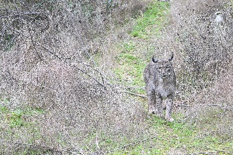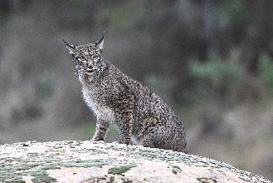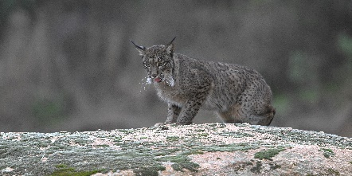

But the Big Cat Year is not only about sightings of Wild Cats. It is also about caring for Nature and its Wildlife. We aim to support one project/organization in each country visited. As such, we selected Fundación CBD-Hábitat, https://cbd-habitat.com/en/about-cbd-habitat/, a NGO which works already a long time time at the Iberian Lynx and its habitat, https://cbd-habitat.com/en/iberian-lynx/. Also, Gato Clavo works together with Fundación CBD-Hábitat and supports it as well, all the more reason to make a donation for this organization and the great work they are doing. In preparing the trip to Andujar, I tried to make an appointment with its director and visit one of the projects they are working on. However, due to the holidays, this was practically impossible to arrange. However, they have expressed their thanks for the donation we transferred and hopefully I will be able to visit them another time to speak to them and get to know more about them and the important work they are doing.
Would you like to contribute to supporting these important projects and/or organizations in the world with regard to conservation and protection and nature of wildlife, please have a look at the funding page, https://mybigcatyear.com/funding . All help is appreciated! Big and small, it all counts. You can already help by buying the projects a coffee, https://buymeacoffee.com/mybigcatyear
Contact: Marc Bozon – marc.bozon@gmail.com - +31654272075
All images can be seen on the Gallery page of Wild Cat Big Year
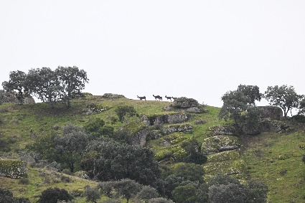 | 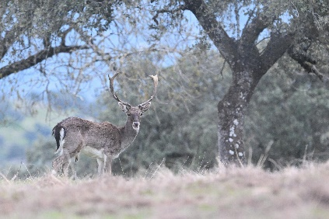 | 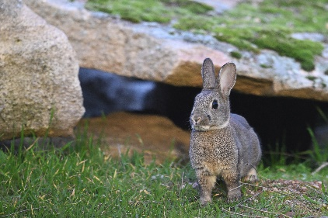
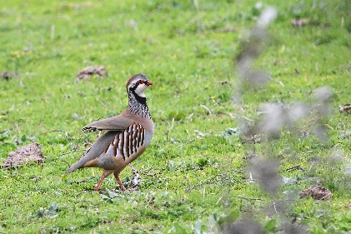 | 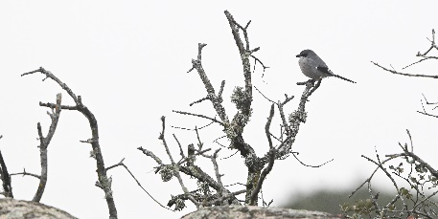 | 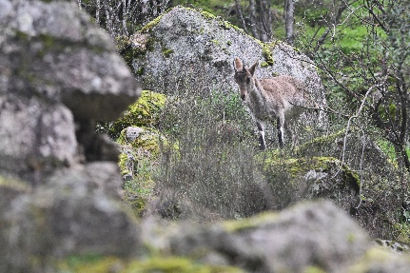

Observed Mammals | Observed Birds
- Europese Red Squirrel - Sciurus vulgaris  - Red Deer - Cervus elaphus  - Fallow Deer - Dama dama  - Iberian Ibex - Capra pyrenaica  - European Rabbit - Oryctolagus cuniculus  - Iberian Lynx - Lynx pardinus  - Red Fox – Vulpus vulpus | - Mallard  - Red-legged Partridge  - Common Wood-Pigeon  - Eurasian Moorhen  - Great Cormorant  - Little Bittern  - Gray Heron  - Common Buzzard  - Little Owl  - Common Hoopoe  - Eurasian Kestrel  - Iberian Gray Shrike  - Iberian Magpie  - Eurasian Magpie  - Common Raven  - Crested Tit  - Great Tit  - Common Chiffchaff  - Eurasian Blackcap  - Sardinian Warbler  - European Starling  - Mistle Thrush  - Eurasian Blackbird  - European Robin  - Black Redstart  - Blue Rock-Thrush  - European Stonechat  - House Sparrow  - Gray Wagtail  - Meadow Pipit  - Common Chaffinch

